**CHAPTER1**

**INTRODUCTION**

**AIM:**The aim of this project is to design and implement a versatile and user-friendly portable website for creating, managing, and publishing articles. The platform will offer a seamless experience for content creators, enabling them to write, format, and enrich their work with multimedia elements. It will feature tools such as a rich text editor, AI-powered content suggestions, image gallery, translation tools, and text-to-speech integration. The platform will also provide robust backend management through an admin panel, ensuring secure and efficient article management and user interaction.

**INTRODUCTION:**

In the digital age, the need for a versatile and user-friendly platform to create, publish, and manage various types of content has never been more essential. The development of a portable website dedicated to articles ranging from journals and news articles to research papers and blogs presents an opportunity to empower content creators with the necessary tools to share valuable knowledge and insights with a global audience. This platform not only simplifies the content creation process but also offers a suite of advanced tools designed to enhance both the user experience and content engagement. Built using **HTML**, **CSS**, **JavaScript**, **PHP**, and **MySQL**, the platform integrates robust backend and frontend features to support seamless management and publishing of content. The content creation process is made easy with a rich text editor that allows authors to write and format their articles, research papers, and blogs effortlessly. Additionally, **CKEditor** integration enables authors to incorporate multimedia elements into their content with ease, ensuring a polished final product. For enhancing the quality and depth of articles, the platform provides a range of advanced tools. Users can organize images with an integrated **image gallery**, access definitions with the **dictionary**, and even use **Gemini AI-powered content suggestions** to generate fresh ideas or refine existing work. Furthermore, an **image editor**, **text-to-speech converter**, **translation tools**, and **reference papers** further equip authors to produce high-quality, accessible content. Additional utilities such as a **word counter**, **FAQ section**, and **downloader** contribute to an even more comprehensive experience, while **rating tools** allow readers to provide feedback to improve the work. User engagement is at the heart of the platform, with features like personalized **user profiles**, content **search** functionality, and **article categorization** that make it easy for readers to find relevant content. A **comment section** enables users to interact with authors and other readers, fostering a sense of community. On the backend, administrators are provided with a user-friendly dashboard to efficiently manage articles, users, and site content. The platform leverages **PHP** and **MySQL** to ensure secure server-side scripting and efficient database management, while **SEO optimization** and **social media sharing** options help to increase the visibility of published articles. Security is also a top priority. As the platform grows, its **scalable database** ensures smooth management of articles, while **API connections** allow for the integration of external data sources and services. Monetization is also a key feature of the platform, as content creators can earn revenue through various methods, making it a profitable space for journalists, researchers, and bloggers alike. Designed with mobile users in mind, the website offers a **responsive design** that ensures seamless access across devices, catering to both professional and personal use. This platform serves as a comprehensive, one-stop solution for researchers, journalists, and content creators, offering the tools they need to create, manage, and publish their work effectively. It meets the growing demand for flexible digital publishing tools, enabling a high level of interactivity, security, and scalability. With advanced features such as **AI-powered content suggestions**, **text-to-speech**, and **translation tools**, the platform improves content accessibility and ensures that it reaches a global audience. The integration of **PHP** for server-side scripting and **MySQL** for database management ensures smooth, secure operations, both for content creators and administrators. As digital content continues to play a central role in communication and knowledge sharing, this portable website project becomes an essential tool for individuals and organizations aiming to produce, share, and monetize content. The platform's **performance** and **security** are prioritized, with the use of **encryption techniques**, **input validation**, and protections against common web vulnerabilities. With a user-friendly interface, robust functionality, and seamless integration with modern web technologies, this platform offers the perfect solution for anyone looking to establish a digital presence focused on article-based content creation, management, and monetization.

**CHAPTER 2**

**SYSTEM ANALYSIS**

**SYSTEM ANALYSIS:**

The system analysis phase for the development of the **Article Portable Website** is a vital step in understanding the functional and non-functional requirements of the platform. This phase involves investigating the needs of various stakeholders such as the website users, administrators, and content creators. It also focuses on analyzing the processes involved in content management, user interaction, and tool integration to design a seamless and efficient solution that aligns with these requirements. This section covers both the **functional** and **non-functional requirements** that define the structure and behavior of the system, along with the technology stack that will support the platform’s development and implementation.

**1. Functional Requirements**

Functional requirements outline the core capabilities and features the website must provide to meet the business objectives. These features must support a wide range of actions for users, content creators, and administrators while ensuring smooth interactions and functionality.

**User-Side Requirements**

1. **User Registration & Authentication**:

* Users must be able to create an account by providing an email address and password.
* Passwords are securely hashed using modern encryption techniques to ensure privacy and security.
* Users should be able to log in, view and edit their profiles.
* The system should allow for secure account recovery and password resetting via email.

1. **Image Slider**:
   * Upon login, users will be greeted with an image slider on the homepage, displaying featured articles, promotions, or content highlights.
   * The slider should automatically rotate and allow users to manually navigate through the images.
2. **Article Exploration**:
   * Users should be able to explore various types of articles.
   * Articles should be well-organized, easily searchable by categories, tags, and keywords.
   * Articles should contain clear descriptions, images, and multimedia elements to enhance the reading experience.
3. **Dashboard**:
   * After logging in, users are directed to their personalized dashboard, where they can access a variety of tools and resources.
   * The dashboard should provide an overview of the most recent articles, news updates, and content suggestions.
4. **Tools Integration**: The platform should feature several useful tools for enhanced user engagement and content interaction:
   1. **Image Gallery**: A gallery where users can browse images related to articles, resources, and blogs.
   2. **Blog Section (FAQ, Gemini AI, Image Editor, Word Processor, Downloader, Reference Papers)**:
      * Users can read FAQs, explore blog posts, and use AI-powered content recommendations via **Gemini AI**.
      * **Image Editor**: Allows users to edit images for personal use, create artwork, or prepare content for sharing.
      * **Word Processor**: A tool for creating and editing documents directly on the website, which users can download in multiple formats.
      * **File Downloader**: A section where users can download content such as reference papers, articles, and other resources.
      * **Reference Paper**: Access to academic papers and articles for deeper research or academic purposes.
5. **Dictionary and Translate**:
   * **Dictionary Tool**: Users can look up the definitions of words directly from articles, blogs, or any other content on the website.
   * **Translate**: A tool to translate content into different languages, increasing accessibility for a wider global audience.
6. **Notes**:
   * Users should have the ability to take personal notes related to articles or blogs they read.
   * Notes should be stored and retrievable for future reference.
7. **Text-to-Speech Conversion**:
   * The website should provide a **text-to-speech** feature that converts articles, blogs, or content into spoken word.
   * Users can listen to the content instead of reading, enabling accessibility for visually impaired users or those who prefer auditory learning.
8. **Website Rating**:
   * After interacting with articles or using the tools, users can provide feedback by rating the website on a scale (e.g., 1-5 stars).
   * This feedback will be used to improve the website and user experience over time.

**Admin-Side Requirements**

1. **Article Management**:
   * Admins must have the ability to create, edit, delete, and categorize articles.
   * Admins should be able to tag articles with relevant keywords and assign them to appropriate categories for better discoverability.
2. **User Management**:
   * Admins should have access to view user accounts, their profile details, activity logs, and interaction history.
   * Admins should be able to reset user passwords and manage account statuses (active, inactive, etc.).
3. **Content Moderation**:
   * Admins should be able to review and approve or reject user-generated content such as comments, notes, or submissions.
   * Admins must ensure content is compliant with community guidelines and policies.
4. **Tool Management**:
   * Admins can manage and update tools integrated into the platform (such as the Image Editor, Translate, Text-to-Speech, etc.).
   * Admins must ensure the tools are functioning correctly and provide troubleshooting support if needed.
5. **Reports & Analytics**:
   * Admins should be able to view detailed reports on website traffic, user engagement, article popularity, and tool usage.
   * Analytics will help admins make data-driven decisions to enhance the platform's content and features.

**2. Non-Functional Requirements**

Non-functional requirements are crucial to ensuring the website performs well and meets user expectations. These include aspects like performance, scalability, security, and usability.

1. **Performance**:
   * The website should have fast loading times, particularly for images, articles, and tools.
   * Articles, images, and multimedia content should be optimized to load quickly, even during periods of high traffic.
2. **Scalability**:
   * The website must be scalable to handle increasing numbers of users, articles, and content as the platform grows.
   * It should support a growing database of articles, user-generated content, and interactive tools.
3. **Security**:
   * User authentication must be secured with modern encryption algorithms such as bcrypt or JWT.
   * All sensitive data, such as user credentials and payment information (if applicable), should be encrypted.
   * Regular backups should be performed to ensure the safety of user data.
4. **Usability**:
   * The website must be intuitive and easy to navigate, with a user-friendly interface for both end users and administrators.
   * Content must be presented in an accessible and engaging way.
   * Tools such as the image editor, word processor, and text-to-speech feature should be simple to use with clear instructions.
5. **Availability**:
   * The platform should have high availability, with minimal downtime to ensure users have constant access to the site.
   * The site should be reliable and should provide quick recovery in case of any issues.
6. **Accessibility**:
   * The platform should comply with WCAG (Web Content Accessibility Guidelines) to ensure it is accessible to users with disabilities.
   * Features like text-to-speech should cater to visually impaired users.
7. **Maintainability**:
   * The website’s architecture should be modular to allow for easy updates, additions of new tools, or improvements to existing features.
   * Documentation for the codebase and administrative processes should be well-maintained for ease of future updates and maintenance.

**3. Technology Stack**

To meet the functional and non-functional requirements, the following technology stack is recommended:

**1. Frontend: HTML5, CSS3, JavaScript Current Setup**: You are using **HTML5**, **CSS3**, and **JavaScript** for the front-end. These are the fundamental building blocks of your website.

* **Recommended Improvement**: To enhance the user experience and make the front-end more dynamic, consider integrating a **JavaScript framework** like **React.js** or **Vue.js**. These frameworks help you build interactive components and provide a smoother user experience by updating the UI efficiently.

**2. Backend: PHP with MySQL Database**

* **Current Setup**: You're using **PHP** as your backend language and **MySQL** as the database. PHP is widely used for building dynamic web applications, and MySQL is an excellent choice for managing structured data like articles, users, and metadata.
* **Recommended Improvement**: Stick with **PHP** if you're comfortable with it. However, consider using a **PHP framework** such as **Laravel** or **Symfony** for better code structure, built-in tools, and easier maintenance. These frameworks can simplify routing, authentication, and database interactions. **API Connection**: For your article website, you can build a **RESTful API** using PHP (e.g., **Slim Framework** or **Laravel**). This API can serve content, handle CRUD operations, and provide interaction with the frontend.
* **Database**: **MySQL** is a solid choice for a relational database to store article data, users, and comments. Be sure to design your schema carefully (e.g., tables for users, articles, categories, etc.) and use **prepared statements** to prevent SQL injection.

**3. Authentication: OAuth, JWT, or Session-Based Authentication**

1. **Current Setup**: If you're handling user registration and login, you can use **session-based authentication**. This is a good option for traditional websites where you store session data on the server.
2. **Recommended Improvement**: If you want to make the authentication more modern, secure, and scalable, consider switching to **JWT (JSON Web Tokens)**. JWT is ideal for stateless authentication and works well with APIs, especially if you have multiple front-end and back-end components (e.g., mobile app, web app).
   * **OAuth**: If you wish to allow users to log in with third-party services (like Google, Facebook, etc.), implement **OAuth 2.0** for social login integration.
   * For **PHP**, libraries like **firebase/php-jwt** can help you handle JWT authentication.

**4. File Storage: AWS S3 for Media and Content**

* **Current Setup**: If you're allowing users to upload images or documents (e.g., for articles), storing these on your server might be fine initially. However, for scalability and performance, it’s better to use cloud storage services like **AWS S3**.
* **Recommended Improvement**: Integrate **AWS S3** for storing images, documents, and user-generated content. S3 offers high availability, scalability, and security for storing and retrieving files.
  + **CKEditor Integration**: CKEditor can be easily configured to upload images directly to **AWS S3**, allowing users to seamlessly add media to their articles.

**5. Text-to-Speech: Google Cloud Text-to-Speech or IBM Watson**

* **Current Setup**: If you wish to implement text-to-speech functionality, **Google Cloud Text-to-Speech** or **IBM Watson** are both excellent choices for converting article content into spoken audio.
* **Recommended Improvement**: Integrate one of these APIs into your site to offer users the ability to listen to articles. For **Google Cloud Text-to-Speech**, you can use **JavaScript** to make API calls to convert text into audio. This feature could be a great accessibility improvement for users who prefer listening over reading.

**6. Translation: Google Translate API for Multi-language Support**

* **Current Setup**: If your website needs to support multiple languages, the **Google Translate API** is an effective way to automatically translate content.
* **Recommended Improvement**: You can integrate the **Google Translate API** into your website, providing users with the ability to translate articles into different languages. Alternatively, you can provide a **language switcher** on the website, so users can manually select the language of their choice.

**7. Image Editor: Fabric.js for Image Processing**

* **Current Setup**: If your site allows users to edit images, **Fabric.js** is an open-source JavaScript library for creating and manipulating images. **Cloudinary** is another great option for handling image uploads and transformations, including cropping, resizing, and optimization.
* **Recommended Improvement**: For more advanced image editing and handling, integrate **Cloudinary**. It provides an easy-to-use interface for uploading and editing images, with built-in CDN support for faster delivery and optimization.
* **Fabric.js** can be used if you want to provide custom image manipulation tools on the client side.

**8. AI Integration: GPT-based AI Tools for Content Recommendations**

1. **Current Setup**: You might want to recommend related articles or generate personalized content for your users.
2. **Recommended Improvement**: Integrate AI-based tools like **GPT** (from OpenAI) or **Gemini AI** to power content recommendations, automatic article summaries, or even content generation based on user preferences.
   * Use GPT-3 or GPT-4 to suggest related articles based on user interests or even auto-generate content like article summaries or introduction

**4.Feasibility Study**

Before moving forward with the development and implementation of the proposed Article portable website, it's essential to conduct a comprehensive feasibility study. This study examines the technical, operational, and financial aspects to ensure that the project is viable and achievable.

**1. Technical Feasibility**

The choice of technologies plays a crucial role in the success of the portable website. For this project, we will leverage **HTML5**, **CSS3**, and **JavaScript** for the front-end design, ensuring compatibility across multiple devices and platforms. For the back-end, the **Node.js** framework with a **NoSQL database** such as **MongoDB** will provide scalability and efficient data management.

* **Resource Availability**: Both front-end and back-end technologies are widely used in the industry, ensuring a broad pool of developers and resources.
* **Support and Documentation**: With strong community support and extensive documentation available, troubleshooting and enhancements become more manageable.
* **Compatibility and Scalability**: The chosen technologies ensure cross-browser and cross-device compatibility, allowing the website to run smoothly on various portable devices, from smartphones to tablets.

**2. Operational Feasibility**

The website will be designed to prioritize user experience, making it intuitive for all users, regardless of technical skill. A responsive layout will automatically adjust to different screen sizes, improving the user experience across various devices.

* **Ease of Use**: The layout and navigation will be simple and accessible, minimizing the need for user training.
* **Scalability**: The website will be optimized for performance, ensuring fast load times even as the site’s traffic and content grow. As the business expands, the system can be scaled up with minimal downtime.
* **Maintenance**: The website will be easy to maintain, with regular updates and bug fixes provided through a streamlined content management system (CMS).

**3. Financial Feasibility**

The financial feasibility of the portable website is supported by its low initial development costs and potential for long-term revenue generation. Since we are utilizing open-source technologies like **PHP**  and **MySQL**, there are no significant licensing costs associated with the project.

* **Initial Development Costs**: The main costs will involve web development resources and possibly third-party APIs or services for added features (e.g., payment gateways or analytics).
* **Long-term Investment**: As the business expands, new features such as a mobile application, enhanced user analytics, and marketing integrations can be added. These updates can increase customer retention and open up additional revenue streams.
* **Return on Investment**: With efficient development and low maintenance costs, the website has the potential to generate a high return on investment by driving traffic, sales, and customer engagement.

**CHAPTER 3**

**SYSTEM REQUIREMENTS**

**SYSTEM REQUIREMENTS:**

**1. Functional Requirements**

**1.1 User Management**

* **User Registration and Login:**
  + **Email/Password Authentication**: Secure login for users.
  + **Social Login**: Integration with Google, Facebook, or other social media platforms for faster user registration/login.
* **User Roles**:
  + **Admin, Vendor (if marketplace)**: Role-based access control for different users.
* **Profile Management**:
* Users can update their profile, change passwords, and manage addresses.

**1.2 Article Management**

* **Admin Features**:
  + Add, edit, delete articles.
  + Bulk upload articles (via CSV/Excel for ease of management).
* **Article Details**:
  + **Title**, **description**, **content**, **tags**, **categories**.
  + Support for text formatting using **CKEditor** (or similar).
* **Variants**:
  + Ability to tag articles by different types (e.g., research papers, reviews).

**1.3 Catalog Browsing**

* **Search Functionality**:
  + **Keyword-based search** with an **advanced filter** option (e.g., by article type, popularity, date).
  + Display search results dynamically in the search bar.
* **Categories**:
  + Multi-level categorization of articles (e.g., Research Papers, How-To Guides, etc.).

**1.4 Dashboard Features**

* **Dashboard Overview**:
  + For users to see articles, statistics, or tools available.
  + **Article Image Gallery**: Users can view image-based content within articles.
* **Search Feature**:
  + Users can search for articles based on keywords, and the result will show matching content in the search bar.

**1.5 Tools Integrated into the Dashboard**

* **Blog Section**:
  + **FAQ**: Help users learn how to write an article, including tips on structure, research, and style.
  + **GEMINI AI API**: Integrate the GEMINI AI for article-related content suggestions or writing assistance.
  + **Word (CKEditor Framework)**: A rich text editor allowing users to write and format their articles.
  + **Downloader (URL Link)**: Users can download images, videos, and PDFs from external sources directly.
  + **Image Editor**: Integrated tools for editing images within articles (e.g., cropping, resizing).
  + **Reference Paper**: A section to guide users on referencing and citing papers for article writing.
* **Notes Management**:
  + Users can create, edit, update, and delete notes regarding their articles.
* **Dictionary (API Integration)**:
  + Provide word meanings or definitions by connecting to an external dictionary API.
* **Translate (API Integration)**:
  + Users can translate text or entire articles using an API like Google Translate.
* **Text-to-Speech Conversion**:
  + Integrate a feature where users can convert article text into speech (audio).
* **Rating System**:
  + Users can rate the quality of the article or website, providing feedback.

**2. Non-Functional Requirements**

**2.1 Performance**

* **Concurrent User Support**: Ability to support a high number of concurrent users (e.g., 1000 simultaneous users).
* **Fast Load Time**: Ensure pages load within 3 seconds for smooth user experience.

**2.2 Scalability**

* The system must support increased traffic during peak times and allow easy feature additions.

**2.3 Security**

* **Data Protection**: Secure data transfer via HTTPS/SSL, and encryption for sensitive data like passwords.
* **Authentication**: Secure login system with role-based access control (e.g., Admin, User, Vendor).
* **Protection Against Threats**: Prevention of SQL injection, XSS, and CSRF attacks.

**2.4 Usability**

* **Mobile-friendly Design**: The platform should be responsive and accessible on mobile devices.
* **Intuitive UI/UX**: Easy navigation to enhance the user experience.

**2.5 Availability**

* **Uptime**: Ensure 99.9% uptime with minimal maintenance downtime.
* **Backup**: Periodic backups and disaster recovery measures.

**2.6 Maintainability**

* **Modular Code**: Clean, modular code for easier maintenance and updates.
* **Comprehensive Documentation**: Document all features, APIs, and tools.

**3. Technical Requirements**

**3.1 Technology Stack**

* **Frontend**:
  + **HTML5**, **CSS3**, **JavaScript** (Frameworks: React, Vue.js).
* **Backend**:
  + **PHP** (Laravel or CodeIgniter).
* **Database**:
  + **MySQL** with proper indexing for efficient searches and data retrieval.

**3.2 Hosting**

* **Cloud Hosting**: Recommended platforms are AWS, DigitalOcean, or VPS for hosting.
* **CDN**: Use a Content Delivery Network (CDN) for faster image and video loading.

**3.3 API Integrations**

* **Third-Party APIs**:
  + **Payment Gateways** (e.g., PayPal, Stripe).
  + **Shipping APIs** (for physical product delivery, if required).
  + **GEMINI AI** (for writing assistance).
* **Custom APIs**:
  + **RESTful API**: For mobile app integration and external integrations.

**3.4 Version Control**

* **Git**: Use Git for version control (GitHub or GitLab for collaboration).

**3.5 Testing**

* **Unit Testing**: Test individual components for proper functionality.
* **End-to-End Testing**: Test the full flow of processes (e.g., from article creation to rating).

**3.6 Deployment**

* **CI/CD Pipeline**: Automated deployment through CI/CD processes for faster updates.
* **Staging Environment**: Test new features before deploying them to production.

**4. Additional Considerations**

* **SEO**: Use proper **schema markup**, meta tags, and URL optimization for better visibility in search engines.
* **Localization**: Multi-language and multi-currency support for global users.
* **Accessibility**: Ensure the platform is WCAG-compliant for accessibility.

**5. Advanced Features**

* **Progressive Web App (PWA)**:
  + Ability to work offline and install the website as an app on mobile devices.
* **AI/ML Integration**:
  + Predictive analytics to suggest trending articles and keywords.
* **Chat and Support**:
  + Real-time chat with AI or live agents, and integration with systems like **Zendesk**.
* **Blockchain Integration**:
  + For transparent article or content tracking and possible crypto payments.
* **Gamification**:
  + Points, badges, and tier-based membership programs (e.g., Bronze, Silver, Gold).

**CHAPTER 4**

**DESIGN AND IMPLEMENTATION**

**4.1.DESIGN**

**1. Requirements Analysis:**

Identify the key features and functionalities for your article portal website:

* **User Registration and Authentication:** Allow users to sign up, log in, and manage their profiles.
* **Welcome Page:** Display a welcome message after users log in.
* **Image Slider:** Highlight featured articles or images.
* **Article Exploration Page:** Allow users to explore articles on various topics such as news, research papers, journals, tourism, etc.
* **Search and Filter:** Enable users to search and filter articles.
* **Dashboard:** Provide users with a personalized dashboard.
* **Image Gallery:** Include a search bar to show images with API connection.
* **Blog:** Allow users to read and write blog posts, including an FAQ section on how to write articles.
* **Integration with Gemini AI:** Use API connections for advanced functionalities.
* **Word CKEditor:** Provide a rich text editor for writing articles.
* **Reference Paper:** Show different types of articles.
* **File Downloader:** Allow users to download images, videos, and PDFs using URLs.
* **Image Editor:** Allow users to edit images.
* **Notes:** Enable users to add, delete, update, and edit notes.
* **Dictionary:** Provide API connection for dictionary functionalities.
* **Translation:** Show all language options to translate text using API connection.
* **Text to Speech:** Convert text to speech.
* **Word Counter:** Count the number of words and letters.
* **Rating System:** Allow users to rate the app.

**2. Architecture Design**

Choose an architecture pattern:

* **Monolithic Architecture:** For simplicity.
* **Microservices Architecture:** For scalability and flexibility.

**3. Database Design**

Design your database schema with essential tables:

* **Users:** Store user details.
* **Articles:** Store article information.
* **Categories:** Store article categories.
* **Comments:** Store user comments on articles.
* **Ratings:** Store user ratings.
* **Images:** Store image details.
* **Files:** Store details of downloadable files.
* **Notes:** Store user notes.

**4. User Interface Design**

Create a user-friendly interface using frameworks like Bootstrap. Key pages include:

* **Login and Register Page**
* **Welcome Page**
* **Image Slider**
* **Article Exploration Page**
* **Search Results Page**
* **Dashboard**
* **Image Gallery**
* **Blog Page (with FAQ)**
* **Notes Management Page**
* **Dictionary Page**
* **Translation Page**
* **Text to Speech Page**
* **Word Counter Page**
* **Rating Page**

**5. Backend Development**

Develop the backend using a suitable programming language and framework PHP. Key components:

* **Authentication Module:** Handle user registration, login, and authentication.
* **Article Management:** CRUD operations for articles.
* **Search and Filter:** Implement search and filtering functionalities.
* **API Integrations:** Connect with Gemini AI, dictionary, and translation APIs.
* **File Management:** Handle file uploads and downloads.
* **Notes Management:** Enable CRUD operations for notes.
* **Rating System:** Manage user ratings.
* **Admin Panel:** For managing articles, users, and site content.

**6. Integration**

Integrate third-party services:

* **Payment Gateway:** If needed for premium features.
* **Email Service:** For notifications and confirmations.
* **API Services:** For dictionary, translation, and AI functionalities.

**7. Security**

Implement security measures:

* **SSL:** For secure data transmission.
* **Input Validation and Sanitization:** Prevent malicious inputs.
* **Password Hashing:** Secure user passwords.
* **Protection against CSRF, XSS, and SQL Injection Attacks.**

**8. Testing**

Perform comprehensive testing:

* **Unit Testing**
* **Integration Testing**
* **End-to-End Testing**
* **Performance Testing**

**9. Deployment**

Deploy the application on a server. Options include:

* **Shared Hosting**
* **Virtual Private Server (VPS)**
* **Cloud Services (e.g., AWS, Azure)**

**10. Maintenance**

Regularly update and maintain the application:

* **Bug Fixes**
* **Security Updates**
* **Feature Enhancements**

**11. Performance Optimization**

Optimize your site for performance:

* **Caching:** Use mechanisms like Redis or Memcached.
* **Database Optimization:** Index important columns, normalize data, and optimize queries.
* **CDN:** Serve static assets through a Content Delivery Network.
* **Lazy Loading:** Load images and resources only when they come into the viewport.

**12. Scalability**

Design your application to handle increased traffic:

* **Horizontal Scaling:** Add more servers.
* **Database Sharding:** Split the database into manageable pieces.
* **Microservices:** Break down the application into independent services.

**13. Advanced Features**

Implement advanced features:

* **GraphQL:** For flexible and efficient data queries.
* **WebSockets:** For real-time communication.
* **Background Jobs:** For tasks like sending emails.

**14. Analytics and Reporting**

Integrate tools to gain insights:

* **Google Analytics:** Track user interactions.
* **Custom Reports:** Generate reports on various metrics.
* **A/B Testing:** Optimize UI/UX and conversion rates.

**15. SEO Best Practices**

Optimize your site for search engines:

* **Structured Data**
* **SEO-Friendly URLs**
* **Meta Tags**
* **Mobile Optimization**

**4.2.IMPLEMENTATION**

**Step 1: Set Up the Development Environment**

1. **Install a Local Server:**
   * **XAMPP:** A cross-platform web server solution stack package with Apache, MariaDB, PHP, and Perl.
   * **WAMP:** A Windows web development environment with Apache2, PHP, and MySQL.
   * **MAMP:** A local server environment for macOS and Windows.

**Step 2: Create the Project Structure**

1. **Organize Directories:**
   * app/: Core application code (models, controllers, middleware).
   * config/: Configuration files.
   * public/: Web server's document root (index.php, asset files).
   * resources/: View templates and raw assets.
   * routes/: Route definitions.
   * storage/: Compiled templates, file-based sessions, file caches, and other generated files.
   * tests/: Test cases.
   * vendor/: Composer dependencies.
   * .env: Environment configuration file.
   * composer.json: Composer configuration file.
   * artisan: Command-line interface for Laravel.

**Step 3: Set Up the Database**

1. **Database Design:**
   * Users: Stores user information (user ID, username, password, email, personal details).
   * Articles: Stores article information (article ID, title, content, category, author).
   * Categories: Stores article categories.
   * Comments: Stores user comments on articles.
   * Ratings: Stores user ratings.
   * Images: Stores image details.
   * Files: Stores details of downloadable files.
   * Notes: Stores user notes.
2. **Database Configuration:**
   * Update the .env file with database credentials.

**Step 4: User Authentication**

1. **User Registration & Login:**
   * Implement functionality for users to create accounts and log in.
   * Use hashing techniques to securely store user passwords.
2. **Session Management:**
   * Manage user authentication using sessions or tokens.

**Step 5: Develop Core Features**

1. **Article Management:**
   * Implement features to add, edit, delete, and list articles.
   * Ensure articles have detailed information such as title, content, category, and author.
2. **Search and Filtering:**
   * Allow users to search for articles by title, category, or other attributes.
   * Provide filtering options for categories, tags, etc.
3. **Image Slider:**
   * Display featured articles or images using an image slider.
4. **User Profile Management:**
   * Enable users to view and edit their profile information.
   * Display past articles in the user profile.
5. **Dashboard:**
   * Create a personalized dashboard for users to manage their content.
6. **Blog:**
   * Allow users to read and write blog posts, including an FAQ section on how to write articles.
7. **Notes:**
   * Enable users to add, delete, update, and edit notes.
8. **File Management:**
   * Allow users to upload and download images, videos, and PDFs using URLs.

**Step 6: Integrate APIs**

1. **Gemini AI Integration:**
   * Connect with Gemini AI for advanced functionalities.
2. **Image Gallery with API Connection:**
   * Implement an image gallery with a search bar connected to an API.
3. **Dictionary API:**
   * Integrate a dictionary API for word definitions.
4. **Translation API:**
   * Show all language options to translate text using an API connection.
5. **Text to Speech:**
   * Convert text to speech.

**Step 7: Implement Additional Features**

1. **Word CKEditor:**
   * Provide a rich text editor for writing articles.
2. **Reference Paper:**
   * Show different types of articles.
3. **Image Editor:**
   * Allow users to edit images.
4. **Word Counter:**
   * Count the number of words and letters.
5. **Rating System:**
   * Allow users to rate the app.

**Step 8: Frontend Development**

1. **Responsive Design:**
   * Use frameworks like Bootstrap or Materialize for a responsive user interface.
2. **Template Engine:**
   * Use a template engine like Blade (if using Laravel) to manage and render HTML templates efficiently.

**Step 9: Testing**

1. **Unit Testing:**
   * Write tests for individual components.
2. **Integration Testing:**
   * Test interactions between components.
3. **End-to-End Testing:**
   * Ensure the entire application works from the user's perspective.
4. **User Acceptance Testing:**
   * Get feedback from real users.

**Step 10: Deployment**

1. **Select Hosting Provider:**
   * Choose a reliable hosting provider (e.g., DigitalOcean, AWS).
2. **CI/CD Pipeline:**
   * Set up a continuous integration and deployment pipeline.
3. **Environment Configuration:**
   * Configure the production environment with necessary settings.

**Step 11: Maintenance**

1. **Monitoring & Logging:**
   * Implement monitoring and logging to track performance and identify issues.
2. **Regular Updates:**
   * Keep the application and dependencies up-to-date.
3. **Backup:**
   * Set up regular backup processes.

**Additional Features & Considerations**

* **SEO Integration:**
  + Ensure SEO-friendly URLs, meta tags, and schema markup are included for optimal search engine performance.
* **Google Analytics Integration:**
  + Track user behavior, session data, and traffic sources to enhance user experience and content strategy.
* **Custom Reports:**
  + Provide custom reports for analyzing sales, user engagement, and content performance.
* **A/B Testing:**
  + Conduct A/B tests to optimize interface and content elements such as UI layouts and marketing strategies.
* **CI/CD Pipeline:**
  + Implement continuous integration and deployment tools like Jenkins or GitLab CI to ensure smooth development and deployment processes.
* **Monitoring and Logging:**
  + Integrate performance monitoring and error tracking tools like New Relic, Prometheus, or Datadog. Use Sentry for error logging and ELK Stack for managing and visualizing logs.

**Backend Considerations**

For the backend of this website, you can use:

* **Backend Frameworks** like Laravel (PHP) and JavaScript to manage APIs and user data.
* **Database:** MySQL or PostgreSQL for managing user data, article content, notes, and other dynamic data.
* **Cloud Hosting:** Consider cloud hosting like AWS, Google Cloud, or DigitalOcean to handle scalability.

**Design and UX/UI**

* **Responsive Design:** Ensure that the website is mobile and tablet-friendly.
* **Interactive Features:** Use JavaScript and frameworks like React.js or Vue.js for dynamic content and interactivity.

**CHAPTER 5**

**ARCHITECTURE DIAGRAM**

**5.1.CLASS DIAGRAM**

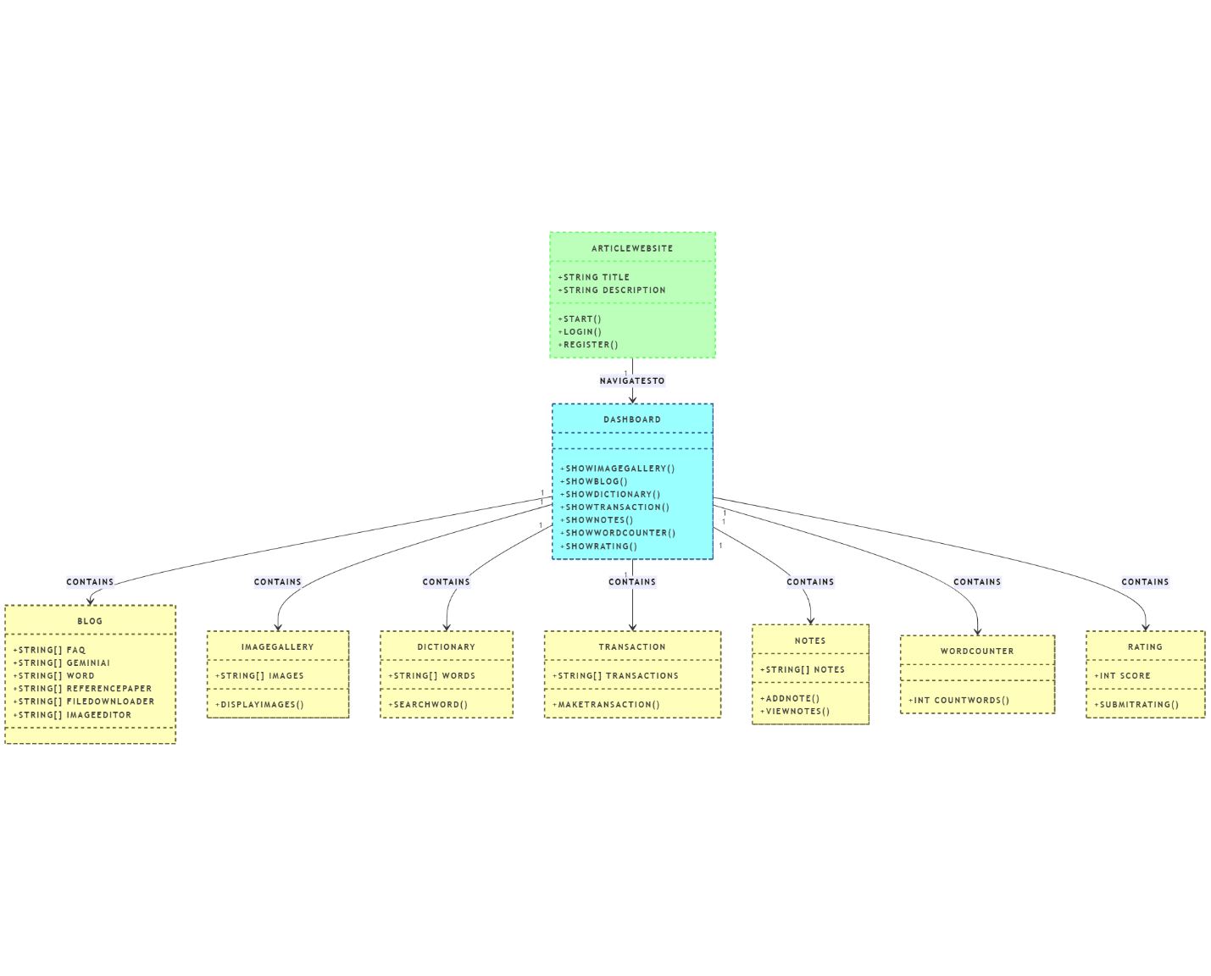

**5.2.STATE DIAGRAM**

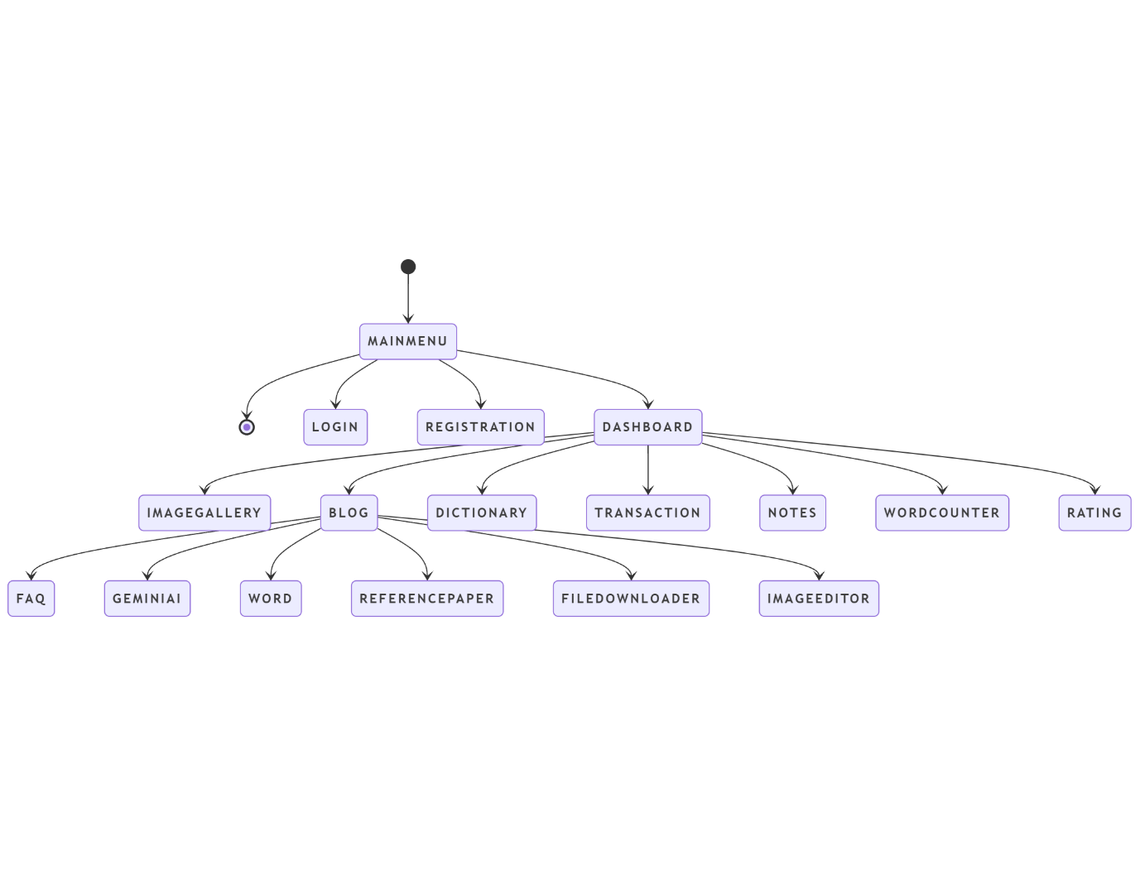

**5.3.ER DIAGRAM**

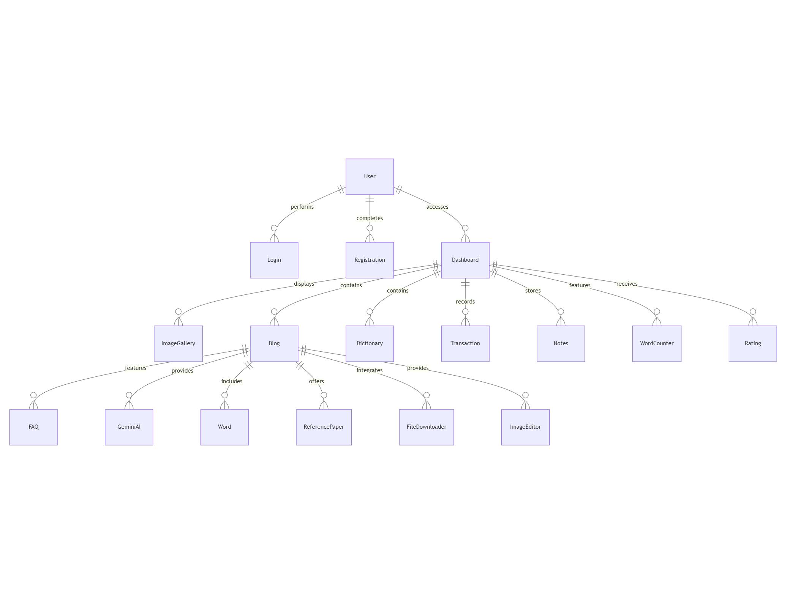

**CHAPTER 6**

**MODULE DESCRIPION**

**1. User Authentication Module (Login and Register)**

*Description*: Manages user registration, login, and authentication for a seamless user experience.

* **Features**:
  + **Registration**: Users can create an account by providing their email, username, and password.
  + **Login**: Users can log in using their credentials.
  + **Password Recovery**: Allows users to reset forgotten passwords.
  + **Two-Factor Authentication (optional)**: Enhances security with an extra layer of protection.

**2.Dashboard Module**

Purpose: After logging in, users are taken to a dashboard where all the features of the website are available and organized.

**Details:**

* Image Gallery: Displays an interactive image gallery, fetching images through an API connection (such as from a cloud storage service or image hosting site). The gallery allows users to view images in an organized, easy-to-navigate way.
* Blog: Provides users with a blog or FAQ section. This section may include articles on various topics like "How to Write Articles," answering common questions and providing guidelines.
* Gemini AI (ChatGPT): Integrates an AI assistant, like ChatGPT, to provide conversational help. Users can ask questions or receive assistance on topics like writing, article suggestions, or any other help they might need.
* Word Processor (CKEditor): Incorporates CKEditor, a rich text editor that lets users create and edit articles, documents, or content on the website. Users can format text, add media, and save their progress.
* Reference Paper: A tool to guide users on how to write articles, research papers, or essays. This section offers instructions, tips, and examples to enhance users' writing skills.
* Downloader: A set of tools that allow users to download PDFs, videos, and images directly from the site. This could be useful for downloading resources or content created on the platform.
* Image Editor: A built-in image editing tool that enables users to upload and modify images (resize, crop, filter, etc.). This allows easy customization for images within the site or for external projects.
* Notes: Users can create, edit, update, and delete notes. It’s an easy way for users to store and manage personal information or writing ideas within the platform.

**3. Dictionary and Translation Module**

**Purpose**: Provides language and communication support for users to enhance their experience.  
**Details**:

* **Dictionary**: Uses an API connection (like Google or Oxford API) to allow users to search for word definitions, synonyms, and related information directly within the website. It helps users understand words better.
* **Translate**: An API integration enables users to translate text into any language. This is beneficial for international users who wish to read or write in different languages.
* **Text to Speech**: Converts written text into speech using a text-to-speech API. This could be helpful for accessibility, allowing users with visual impairments to interact with the content more easily.

**4. Rating and Feedback Module**

**Purpose**: Allows users to rate their experience with the website and provide valuable feedback.  
**Details**:

* **Rating**: Users can rate the website using a star system (e.g., 1 to 5 stars). This feedback helps assess user satisfaction and website performance.
* **Feedback**: Users can submit additional comments or feedback on how the website can be improved, or their experience using specific features. This could be an optional form allowing for open-ended responses.

**5. API Integration Features**

Some of the core features listed earlier rely on API integration to work smoothly. These APIs would include:

* **Image Gallery API**: Fetches images from a cloud or external server and displays them on the site.
* **Dictionary API**: Provides real-time definitions, synonyms, and translations for words.
* **Text-to-Speech API**: Converts on-screen text into audible speech for users.
* **Translation API**: Instantly translates text between different languages.

**Additional Features Summary:**

* **Gemini AI (ChatGPT)**: Users can interact with AI for conversational help, problem-solving, writing suggestions, and more.
* **CKEditor**: Rich text editor for writing and editing articles, allowing for formatting, adding images, and saving documents.
* **Reference Paper**: A resource section for writing guidance, specifically for academic papers and articles.
* **Downloader**: A tool for downloading files like PDFs, videos, and images. This feature supports users by allowing them to retrieve important content.
* **Image Editor**: Provides an easy-to-use tool to edit images. Users can crop, resize, and add filters or effects to photos.
* **Notes**: A space where users can take and manage personal notes, making the platform a flexible tool for both work and personal projects.

**CHAPTER 7**

**CODING AND TESTING**

**7.1.CODING:**

**1. User Authentication and Authorization**

**Purpose:**  
This module ensures that users can securely log in, register, and manage their sessions. It handles user authentication with secure password hashing and session management.

**Features:**

* **Registration & Login:**
  + Users can create an account or log in using their credentials (username, email, and password).
  + Passwords are hashed using PHP’s password_hash() for security.
  + Once logged in, sessions are created and maintained using PHP session variables.
* **Session Management:**
  + Sessions are used to store user-specific data (like shopping cart items or saved notes).
  + This allows users to seamlessly navigate between pages without losing data.

**2. Dashboard**

After successful login, users are directed to the **Dashboard**, which provides quick access to the key features.

**Features:**

* **Image Gallery:**
  + Display a dynamic gallery of images fetched using an API connection (e.g., Unsplash, Pexels).
  + The images are presented as thumbnails, and users can click to view full-sized images.
* **Blog Section & FAQ:**
  + This section helps users understand how to write articles and provides general FAQs about using the platform.
  + Users can read articles about writing techniques, tips for good writing, and formatting.
* **Gemini AI (ChatGPT Integration):**
  + Integrate **Gemini AI** (ChatGPT) to assist users in content generation or answering queries.
  + This tool can help generate article ideas, suggestions, and more.
* **Word (CKEditor):**
  + Users can create and edit articles using **CKEditor**, a rich text editor, which allows them to format text, insert images, and more.
* **Reference Paper:**
  + This section shows guidance on writing articles or research papers, offering users templates and tips for structure, citations, and other essential aspects.
* **Downloader (PDF, Videos, Images):**
  + Users can download articles, videos, images, or other resources for offline use.
* **Image Editor:**
  + An integrated image editor allows users to upload and edit images (resize, crop, and apply filters) directly within the platform.
* **Notes Management:**
  + Users can add, edit, update, and delete notes within their account. Notes are stored in the database for easy retrieval.
* **Dictionary (API Integration):**
  + Integrate a dictionary API (e.g., Google or Oxford) to help users search for word definitions, synonyms, and meanings.
* **Translate (API Integration for All Languages):**
  + Users can translate text into multiple languages, making the platform accessible to a global audience.
* **Text-to-Speech:**
  + Convert text into speech using a text-to-speech API (e.g., Google Text-to-Speech), enhancing accessibility.
* **Rating:**
  + Users can rate the website on a scale (1-5 stars), providing feedback on user experience and satisfaction.

**3. Backend: PHP and MySQL**

**Purpose:**  
PHP and MySQL will be used to power the backend, handling user data, product management, orders, and security.

**Features:**

* **Database Design:**
  + Design MySQL tables to store user accounts, notes, images, product information, orders, etc.
  + Tables include: users, products, orders, notes, images, downloads, ratings, etc.
  + Relationships between tables (e.g., a user can have many orders, one product can belong to many orders).
* **PHP Scripting:**
  + PHP will be used to handle various functionalities such as registration, login, user sessions, note management, and order processing.
  + It will also handle API integrations for the image gallery, dictionary, translation, and text-to-speech.
* **Security:**
  + **SQL Injection Prevention:** Use prepared statements with parameterized queries to prevent SQL injection attacks.
  + **Password Hashing:** Store passwords securely using password_hash() to protect user data.
  + **SSL Encryption:** Ensure sensitive data (like passwords and payment information) is encrypted using SSL.

**4. Payment Integration and Order Management (Optional)**

**Purpose:**  
If applicable, this module manages the checkout process, payment integration, and order tracking.

**Features:**

* **Payment Gateway Integration:**
  + Integrate PayPal, Stripe, or another secure payment gateway for transaction processing.
* **Order Management:**
  + Users can view and manage their orders, track order statuses, and confirm purchases.
  + When a user completes a purchase, an order record is inserted into the database, and inventory is updated.

**5. Frontend: HTML, CSS, and JavaScript**

**Purpose:**  
The frontend of the platform will be responsible for the user interface, ensuring that the platform is responsive, interactive, and easy to use.

**Features:**

* **Responsive Design:**
  + The website will adapt to various screen sizes, ensuring that users on both desktop and mobile devices have an optimal experience.
* **User Interface (UI):**
  + Simple, clean, and intuitive navigation to access all modules (gallery, blog, editor, dictionary, etc.).
  + Use **CSS** for styling and **JavaScript** for interactive elements (like image gallery sliders, AJAX calls for API data, etc.).
* **SEO and Performance Optimization:**
  + Implement search engine optimization (SEO) best practices to ensure the site ranks well on search engines.
  + Ensure the website is optimized for fast load times by compressing images, minifying CSS/JS, and using asynchronous loading.

**6. Customer Support and Feedback**

**Purpose:**  
This section provides users with the support they need and gathers valuable feedback.

**Features:**

* **Customer Service:**
  + Live chat, email support, and a helpdesk can help resolve issues related to account management, notes, or other platform features.
* **FAQ Section:**
  + A comprehensive FAQ section addressing common questions and issues users might encounter.
* **User Ratings and Feedback:**
  + Users can rate their experience and provide suggestions to help improve the website.

**7. SEO and Digital Marketing**

**Purpose:**  
To help the platform gain visibility and attract users through search engines and marketing strategies.

**Features:**

* **SEO Optimization:**
  + Product pages, blogs, and other content are optimized for search engines using keywords, meta tags, and structured data.
* **Marketing Strategies:**
  + Implement email marketing, social media campaigns, and paid advertising to attract and retain users.
  + Offer discount codes, coupons, and promotions to drive sales and engagement.

**7.2.TESTING**

**1. System Architecture and Structure Testing**

**Frontend vs Backend Integration**

* **Frontend (HTML, CSS, JavaScript):**
  + **User Interface Testing:** Verify that the login and registration pages are visually appealing, and all elements (forms, buttons, images) load properly.
  + **Responsive Design Testing:** Test on different devices (desktop, tablet, mobile) to ensure the layout adapts and remains functional.
  + **JavaScript Validation:** Ensure the login and registration forms validate input (e.g., email format, password strength) on the client side before sending data to the server.
* **Backend (PHP, MySQL):**
  + **Database Testing:** Ensure that the database tables (e.g., users, notes, articles, etc.) are set up correctly in MySQL and that relationships between entities (e.g., users and articles) are well-defined.
  + **CRUD Operations Testing:** Verify that PHP scripts handle creating, reading, updating, and deleting data correctly for all sections (users, articles, notes).
  + **MVC Structure Testing:** Ensure that the Model-View-Controller architecture is followed, with PHP controlling the data flow, HTML displaying the view, and JavaScript handling user interactions.

**2. User Authentication and Authorization Testing**

**Registration and Login**

* **Test User Registration:**
  + Validate that users can register with correct email formats and strong passwords.
  + Test email uniqueness and secure password hashing using PHP’s password_hash().
* **Test User Login:**
  + Ensure the system properly authenticates users with correct credentials.
  + Test for appropriate error messages when incorrect credentials are entered.
  + Validate session management and user redirection to the dashboard once logged in.
* **Admin vs Regular User Access:**
  + Verify that admins have extra privileges (e.g., add/edit articles) and regular users can access only their personal content and dashboard.

**3. Dashboard Testing**

**Content Display (Image Gallery, Blog, Notes, etc.)**

* **Image Gallery:**
  + **API Integration Testing:** Verify that images are fetched correctly from the API and displayed in the gallery section of the dashboard.
  + **Image Display:** Ensure the images appear with the correct formatting and dimensions, and there is no distortion or overlap.
* **Blog Section:**
  + **Content Display:** Ensure that articles, FAQs, and how-to guides (e.g., "How to write an article") are visible and correctly formatted.
  + **Text Editor Testing:** Test that users can write and save articles using the Word (CKEditor) and see the results in the blog section.
* **Gemini AI (ChatGPT Integration):**
  + **Chat Functionality Testing:** Test that the Gemini AI (similar to ChatGPT) is functional, responding appropriately to user queries, and providing suggestions related to article writing or FAQ help.

**4. API Integration Testing**

**Dictionary and Translation API**

* **Dictionary API Testing:**
  + Verify that the dictionary feature can fetch correct definitions or translations from an external API.
* **Translate API Testing:**
  + Ensure that the translation feature works for multiple languages and returns accurate translations when text is input by the user.
* **Text-to-Speech Conversion:**
  + Test the text-to-speech conversion by inputting text and verifying that the system reads it out loud correctly.

**5. Image Editing and Downloader Features Testing**

**Image Editor:**

* **Test Image Upload and Editing:**
  + Ensure users can upload images and use the editor to modify them (resize, crop, adjust brightness/contrast).
* **Download Functionality Testing:**
  + Test that users can download PDF, images, and videos successfully from the platform.

**Downloader (PDF, Videos, Images):**

* **Test File Download:**
  + Verify that users can successfully download files (images, PDF documents, videos) by clicking the download links.

**6. Notes Management Testing**

**Create, Edit, Update, and Delete Notes:**

* **CRUD Operations Testing for Notes:**
  + Ensure users can add, edit, update, and delete notes without errors.
  + Validate that changes to notes are reflected in the database and on the dashboard.

**7. Payment Processing and Transaction Security**

* **Payment Gateway Testing (if applicable):**
  + If the platform allows paid services or premium content, ensure that payment gateways (like PayPal or Stripe) are integrated correctly.
  + Test the security of payment data with SSL encryption and ensure that no sensitive data is stored directly in the database.

**8. Security Practices Testing**

**Protection Against Attacks**

* **SQL Injection Testing:**
  + Ensure all user inputs (registration, login, search, article submission) are properly sanitized and use prepared statements to prevent SQL injection attacks.
* **Cross-Site Scripting (XSS) Protection:**
  + Test that all user-generated content (articles, comments, notes) is properly escaped and sanitized to prevent XSS vulnerabilities.
* **Cross-Site Request Forgery (CSRF) Testing:**
  + Ensure that CSRF tokens are implemented and validate that no unauthorized requests can be made on behalf of users.

**Encryption and Data Protection**

* **SSL/TLS Testing:**
  + Verify that the entire website uses HTTPS to secure the transmission of sensitive data, including login credentials and transactions.
* **Data Privacy Testing:**
  + Ensure that personal data is encrypted and that the platform complies with data protection regulations like GDPR and CCPA.

**9. User Experience (UX) and Interface Testing**

**Responsive Design Testing**

* **Test on Various Devices:**
  + Ensure that the website adapts to different screen sizes (mobile, tablet, desktop) without breaking the layout or usability.
* **Navigation Testing:**
  + Verify that the navigation bar is intuitive, and all pages (dashboard, articles, image gallery) are easily accessible.
* **Performance Testing:**
  + Test page load times for different sections (dashboard, image gallery, blog) to ensure fast performance even with heavy traffic.
  + Implement caching strategies to optimize loading times.

**10. SEO and Marketing Integration Testing**

**SEO Optimization**

* **SEO Tags and Metadata Testing:**
  + Ensure each page has correct meta descriptions, title tags, and clean URLs for better search engine visibility.
* **Content Marketing Testing:**
  + Verify that content such as blog posts, articles, and FAQs are correctly indexed by search engines.

**11. Scalability and Maintenance Testing**

**Scalability Testing**

* **Stress Testing:**
  + Simulate high traffic to ensure that the platform can handle a growing number of users (100+ simultaneous users) without crashing.

**Ongoing Maintenance Testing**

* **Updates and Patches Testing:**
  + Test how the platform handles software updates (security patches, new features) without affecting existing functionality.

**CHAPTER 8**

**SOURCE CODE**

**Login.html**

<!DOCTYPE html>

<html lang="en">

<head>

<meta charset="UTF-8">

<meta http-equiv="X-UA-Compatible" content="IE=edge">

<meta name="viewport" content="width=device-width, initial-scale=1.0">

<link href='https://unpkg.com/boxicons@2.1.4/css/boxicons.min.css' rel='stylesheet'>

<link rel="stylesheet" href="style.css">

<title>Ludiflex | Login & Registration</title>

</head>

<body>

<div class="wrapper">

<nav class="nav">

<div class="nav-logo">

<p>ARTICLES PORTABLE WEBSITE</p>

</div>

<div class="nav-menu" id="navMenu">

<ul>

<li><a href="#" class="link active">Home</a></li>

<li><a href="#" class="link">Blog</a></li>

<li><a href="#" class="link">Services</a></li>

<li><a href="#" class="link">About</a></li>

</ul>

</div>

<div class="nav-button">

<button class="btn white-btn" id="loginBtn" onclick="login()">Sign In</button>

<button class="btn" id="registerBtn" onclick="register()">Sign Up</button>

</div>

<div class="nav-menu-btn">

<i class="bx bx-menu" onclick="myMenuFunction()"></i>

</div>

</nav>

<!-- Form box -->

<div class="form-box">

<!-- Login form -->

<div class="login-container" id="login">

<div class="top">

<span>Don't have an account? <a href="#" onclick="register()">Sign Up</a></span>

<header>Login</header>

</div>

<div class="input-box">

<input type="text" class="input-field" placeholder="Username or Email" id="loginUsername">

<i class="bx bx-user"></i>

</div>

<div class="input-box">

<input type="password" class="input-field" placeholder="Password" id="loginPassword">

<i class="bx bx-lock-alt"></i>

</div>

<div class="input-box">

<input type="submit" class="submit" value="Sign In" id="loginSubmit">

</div>

<div class="two-col">

<div class="one">

<input type="checkbox" id="login-check">

<label for="login-check"> Remember Me</label>

</div>

<div class="two">

<label><a href="#">Forgot password?</a></label>

</div>

</div>

</div>

<!-- Registration form -->

<div class="register-container" id="register">

<div class="top">

<span>Have an account? <a href="#" onclick="login()">Login</a></span>

<header>Sign Up</header>

</div>

<div class="two-forms">

<div class="input-box">

<input type="text" class="input-field" placeholder="Firstname" id="registerFirstName">

<i class="bx bx-user"></i>

</div>

<div class="input-box">

<input type="text" class="input-field" placeholder="Lastname" id="registerLastName">

<i class="bx bx-user"></i>

</div>

</div>

<div class="input-box">

<input type="text" class="input-field" placeholder="Email" id="registerEmail">

<i class="bx bx-envelope"></i>

</div>

<div class="input-box">

<input type="password" class="input-field" placeholder="Password" id="registerPassword">

<i class="bx bx-lock-alt"></i>

</div>

<div class="input-box">

<input type="submit" class="submit" value="Register" id="registerSubmit">

</div>

<div class="two-col">

<div class="one">

<input type="checkbox" id="register-check">

<label for="register-check"> Remember Me</label>

</div>

<div class="two">

<label><a href="#">Terms & conditions</a></label>

</div>

</div>

</div>

</div>

</div>

<script>

// Menu function for mobile view

function myMenuFunction() {

var i = document.getElementById("navMenu");

if(i.className === "nav-menu") {

i.className += " responsive";

} else {

i.className = "nav-menu";

}

}

// Functions for switching between login and register

var a = document.getElementById("loginBtn");

var b = document.getElementById("registerBtn");

var x = document.getElementById("login");

var y = document.getElementById("register");

function login() {

x.style.left = "4px";

y.style.right = "-520px";

a.className += " white-btn";

b.className = "btn";

x.style.opacity = 1;

y.style.opacity = 0;

}

function register() {

x.style.left = "-510px";

y.style.right = "5px";

a.className = "btn";

b.className += " white-btn";

x.style.opacity = 0;

y.style.opacity = 1;

}

// Login submit handler

document.getElementById("loginSubmit").addEventListener("click", function(e) {

e.preventDefault();  // Prevent the form from submitting

// Perform form validation here if needed

window.location.replace('welcome.html');  // Redirect to next page

});

// Register submit handler

document.getElementById("registerSubmit").addEventListener("click", function(e) {

e.preventDefault();  // Prevent the form from submitting

// Perform form validation here if needed

window.location.replace('welcome.html');  // Redirect to next page

});

</script>

</body>

</html>

**Home.html**

<!DOCTYPE html>

<!-- Coding by CodingNepal || www.codingnepalweb.com -->

<html lang="en">

<head>

<meta charset="UTF-8" />

<meta http-equiv="X-UA-Compatible" content="IE=edge" />

<meta name="viewport" content="width=device-width, initial-scale=1.0" />

<title>Hoverable Sidebar Menu HTML CSS & JavaScript</title>

<link rel="stylesheet" href="main style.css" />

<!-- Boxicons CSS -->

<link href="https://unpkg.com/boxicons@2.1.4/css/boxicons.min.css" rel="stylesheet" />

<script src="main script.js" defer></script>

</head>

<style>

h1 {

background-color: rgb(19, 22, 60);

color: white;

text-align: center;

margin: 0;

padding: 20px;

}

.search-container {

display: flex;

justify-content: center;

margin-top: 20px;

width: 100%;

padding: 0 30px;

}

form {

position: relative;

transition: all 1s;

width: 50px;

height: 50px;

background: hwb(280 13% 51%);

box-sizing: border-box;

border-radius: 25px;

border: 4px solid #140f41;

padding: 5px;

}

input {

position: absolute;

top: 0;

left: 0;

width: 100%;

height: 42.5px;

line-height: 30px;

outline: 0;

border: 0;

display: none;

font-size: 1em;

border-radius: 20px;

padding: 0 20px;

}

.fa {

box-sizing: border-box;

padding: 10px;

width: 42.5px;

height: 42.5px;

position: absolute;

top: 0;

right: 0;

border-radius: 50%;

color: #8c52ff;

text-align: left;

font-size: 1.2em;

transition: all 1s;

}

form:hover {

width: 300px;

cursor: pointer;

}

form:hover input {

display: block;

}

form:hover .fa {

background: hsl(259, 76%, 8%);

color: white;

}

/* Styling for the h2 tag */

h2 {

width: 80%;

color: hwb(0 5% 12%);

margin: 30px auto;

text-align: center;

font-size: 2em; /* Adjusted font size for emphasis */

}

/* Styling for the image container */

.image

{  display: flex;

justify-content: center;

align-items: center;

margin-top: 20px; /* Optional: adds space above the image */

}

/* Styling for the p tag */

p {

width: 80%;

color: #060606;

margin: 30px auto;

padding:2px;

box-sizing: border-box;

line-height: 1.6;

font-size: 1.2em;

text-align: justify; /* Changed from center to justify for better readability */

}

</style>

</head>

<body>

<!-- Search form wrapped inside a centered container -->

<div>

<h1>Article Portable Website</h1>

</div>

<div class="search-container">

<form action="Paper-section">

<input type="search" id="search" placeholder="Search here ...">

<i class="fa fa-search"></i>

</form>

</div>

<!-- Content Section -->

<div>

<h2>what is Article</h2>

<p>An article is long-form content written on a particular topic to be published online or offline, appropriate content.</p>

<!-- Image Section -->

<div class="image">

<img src="articalimg.jpg" alt="Article Image">

</div>

<p>An article paper is a written work that provides information, insights, or opinions about a particular topic when they are published in academic journals, magazines, or newspapers.</p>

</div>

<!-- Another Content Section -->

<div>

<h2>Magazine Article</h2>

<p>A magazine article is engaged throughout your article.</p>

<div class="image">

<img src="articalimg1.jpg" alt="Article Image">

</div>

<p>There are many types of magazine articles, each with their own unique purpose and style. News articles, This will help you tailor your article to their needs and interests, making it more engaging and relevant to them.</p>

</div>

<!-- Another Content Section -->

<div>

<h2>News Article</h2>

<p>A news article is the finished product or piece of writing that results from newswriting. Unlike other types of writing, succinct, structured format.</p>

<div class="image">

<img src="article2.avif" alt="Article Image">

</div>

<p>A regularly published collection of fairly brief articles that provide updates on current events and interests express opinions on timely topics and invite their readers to submit their opinions.</p>

</div>

<!-- Another Content Section -->

<div>

<h2>Journal Article</h2>

<p>Journal articles are the mainstay of academic publishing. They are original, peer-

anywhere else. Plus, they can help you when you’re doing research.</p>

<div class="image">

<img src="journal.jpg" alt="Article Image">

</div>

<p>Here are a few examples collected by our Book Writing Founders UK expert researchers. These </p>

</div>

<!-- Another Content Section -->

<div>

<h2>Travel Article</h2>

<p>Sometimes our beautiful world seems like a scary place. The news that we are drip-fed through </p>

<div class="image">

<img src="travel.avif" alt="Article Image">

</div>

<p>Travel writing can be defined as writing that describes places and popular magazines, in specialist travel publications, or online in blogs and on websites.</p>

</div>

<!-- Another Content Section -->

<div>

<h2>Personal Article</h2>

<p>Every day, captures the same kind of emotion we exude when we’re sharing them face-to-face.Guy Fieri says. Here are nine ways to infuse flavor:</p>

<div class="image">

<img src="personal.jpeg" alt="Article Image">

</div>

<p>Powerful essays resonate with the reader; they ring true. They can also validate what you feel or believe. You don’t have to write about a hurt.</p>

</div>

<script>// Selecting the search input and all content sections

var search = document.getElementById("search");

var paperSections = document.querySelectorAll("div > h2");  // Targets the h2 tags within the content sections

// If the paper name does not match the search input, hide that section

if (paperName.toUpperCase().indexOf(enteredValue) < 0) {

section.parentElement.style.display = "none";  // Hide the parent element of the <h2> (the content section)

} else {

section.parentElement.style.display = "block";  // Show the parent element if it matches the search

}

});

});</script>

</div>

<!-- Sidebar Section -->

<nav class="sidebar locked">

<span>CREATE</span>

<i class="bx bx-lock-alt" id="lock-icon" title="Unlock Sidebar"></i>

<i class="bx bx-x" id="sidebar-close"></i>

<div class="menu_container">

<div class="menu_items">

<ul class="menu_item">

<div class="menu_title flex">

<span class="title">Home</span>

<span class="line"></span>

</div>

<li class="item">

<a href="image.html" class="link flex">

<i class="bx bx-image-alt"></i>

<span>Image gallery</span>

</a>

</li>

<li class="item">

<a href="flex.html" class="link flex">

<i class="bx bx-grid-alt"></i>

<span>Blog</span>

</a>

</li>

</ul>

<ul class="menu_item">

<div class="menu_title flex">

<span class="title">Dashboard</span>

<span class="line"></span>

</div>

<li class="item">

<a href="note.html" class="link flex">

<i class="bx bxs-magic-wand"></i>

<span>Notes</span>

</a>

</li>

<li class="item">

<a href="dict.html" class="link flex">

<i class="bx bx-folder"></i>

<span>Dictionary</span>

</a>

</li>

<li class="item">

<a href="trans.html" class="link flex">

<i class="bx bx-text to speech"></i>

<span>Translate</span>

</a>

</li>

</ul>

<ul class="menu_item">

<div class="menu_title flex">

<span class="title">Setting</span>

<span class="line"></span>

</div>

<li class="item">

<a href="wordcount.html" class="link flex">

<i class="bx bx-flag"></i>

<span>Word Count</span>

</a>

</li>

<li class="item">

<a href="textspeech.html" class="link flex">

<i class="bx bx-award"></i>

<span>Text to Speech</span>

</a>

</li>

<li class="item">

<a href="star.html" class="link flex">

<i class="bx bx-star"></i>

<span>Rating</span>

</a>

</li>

</ul>

</div>

</div>

</nav>

</body>

</html>

list-style: none;

}

.link {

text-decoration: none;

border-radius: 8px;

margin-bottom: 8px;

color: hsl(0, 18%, 92%);

}

.link:hover {

color: hsl(0, 0%, 4%);

background-color: hwb(4 3% 13%);

}

.link span {

white-space: nowrap;

}

.link i {

height: 50px;

min-width: 55px;

display: flex;

font-size: 22px;

align-items: center;

justify-content: center;

border-radius: 4px;

}

.sidebar_profile {

padding-top: 15px;

margin-top: 15px;

gap: 15px;

border-top: 2px solid rgba(220, 55, 55, 0.1);

}

.sidebar_profile .name {

font-size: 18px;

color: #e8e3e3;

}

.sidebar_profile .email {

font-size: 15px;

color: #0d0d0d;

}

/* Responsive */

@media screen and (max-width: 1100px) {

.navbar {

left: 65%;

}

}

@media screen and (max-width: 800px) {

.sidebar {

left: 0;

z-index: 1000;

}

.sidebar.close {

left: -100%;

}

#sidebar-close {

display: block;}

#lock-icon {

display: none;

}

.navbar {

left: 0;

max-width: 100%;

transform: translateX(0%);

}

#sidebar-open {

display: block;

}

}

// Selecting the sidebar and buttons

const sidebar = document.querySelector(".sidebar");

const sidebarOpenBtn = document.querySelector("#sidebar-open");

const sidebarCloseBtn = document.querySelector("#sidebar-close");

const sidebarLockBtn = document.querySelector("#lock-icon");

// Function to toggle the lock state of the sidebar

const toggleLock = () => {

sidebar.classList.toggle("locked");

// If the sidebar is not locked

if (!sidebar.classList.contains("locked")) {

sidebar.classList.add("hoverable");

sidebarLockBtn.classList.replace("bx-lock-alt", "bx-lock-open-alt");

} else {

sidebar.classList.remove("hoverable");

sidebarLockBtn.classList.replace("bx-lock-open-alt", "bx-lock-alt");

}

};

// Function to hide the sidebar when the mouse leaves

const hideSidebar = () => {

if (sidebar.classList.contains("hoverable")) {

sidebar.classList.add("close");

}

};

// Function to show the sidebar when the mouse enter

const showSidebar = () => {

if (sidebar.classList.contains("hoverable")) {

sidebar.classList.remove("close");

}

};

// Function to show and hide the sidebar

const toggleSidebar = () => {

sidebar.classList.toggle("close");

};

// If the window width is less than 800px, close the sidebar and remove hoverability and lock

if (window.innerWidth < 800) {

sidebar.classList.add("close");

sidebar.classList.remove("locked");

sidebar.classList.remove("hoverable");

}

// Adding event listeners to buttons and sidebar for the corresponding actions

sidebarLockBtn.addEventListener("click", toggleLock);

sidebar.addEventListener("mouseleave", hideSidebar);

sidebar.addEventListener("mouseenter", showSidebar);

sidebarOpenBtn.addEventListener("click", toggleSidebar);

sidebarCloseBtn.addEventListener("click", toggleSidebar);

**IMAGE.HTML**

<!DOCTYPE html>

<html lang="en" dir="ltr">

<head>

<meta charset="utf-8">

<title>Image Gallery with JavaScript | CodingNepal</title>

<link rel="stylesheet" href="image.css">

<meta name="viewport" content="width=device-width, initial-scale=1.0">

<link rel="stylesheet" href="https://unicons.iconscout.com/release/v4.0.0/css/line.css">

<script src="image.js" defer></script>

<style>

/* Style for the buttons */

.navigation-buttons {

position: fixed;

top: 10px;

width: 100%;

display: flex;

justify-content: space-between;

padding: 0 20px;

z-index: 10;

}

.navigation-buttons button {

background-color: #333;

color: white;

border: none;

padding: 10px 20px;

cursor: pointer;

font-size: 16px;

}

.navigation-buttons button:hover {

background-color: #555;

}

</style>

</head>

<body>

<!-- Navigation Buttons -->

<div class="navigation-buttons">

<button id="back-button">Back</button>

<button id="next-button">Next</button>

</div>

<div class="lightbox">

<div class="wrapper">

<header>

<div class="photographer">

<i class="uil uil-camera"></i>

<span></span>

</div>

<div class="buttons">

<i class="uil uil-import"></i>

<i class="close-icon uil uil-times"></i>

</div>

</header>

<div class="preview-img">

<div class="img"><img src="" alt="preview-img"></div>

</div>

<section class="search">

<img src="personal.jpeg" alt="search-img">

<div class="content">

<h1>Image Gallery</h1>

<p>Search and download any images within a second</p>

<div class="search-box">

<i class="uil uil-search"></i>

<input type="text" placeholder="Search images">

</div>

</div>

</section>

<section class="gallery">

<ul class="images"></ul>

<button class="load-more">Load More</button>

</section>

<script>

// Event listener for the Back button

document.getElementById('back-button').addEventListener('click', function() {

window.location.href = 'main.html'; // Replace with your previous page URL

});

// Event listener for the Next button

document.getElementById('next-button').addEventListener('click', function() {

window.location.href = 'flex.html'; // Replace with your next page URL

});

</script>

</body>

</html>

**FLEX.HTML**

<!DOCTYPE html>

<html lang="en">

<head>

<meta charset="UTF-8">

<meta name="viewport" content="width=device-width, initial-scale=1.0">

<title>Flexbox Layout</title>

<link rel="preconnect" href="https://fonts.googleapis.com">

<link rel="preconnect" href="https://fonts.gstatic.com" crossorigin>

<link href="https://fonts.googleapis.com/css2?family=Poppins:wght@400;500&display=swap" rel="stylesheet">

<link rel="stylesheet" href="flex style.css">

<body>

<div>

<h1 style="text-align: center;">Welcome</h1>

</div>

<div class="container">

<!-- First row of 3 items -->

<div class="item">

<img src="fimg1.jpg" alt="video">

<button onclick="location.href='flexbox1.html'">FAQ Accordion</button>

</div>

<div class="item">

<img src="fimg2.jpg" alt="introduction">

<button onclick="location.href='flex2chat.html'">Gemini Chatbot</button>

</div>

<div class="item">

<img src="fimg3.png" alt="chatgpt">

<button onclick="location.href='ckeditor5-builder-44.1.0/index.html'">Words</button>

</div>

<!-- Second row of 3 items -->

<div class="item">

<img src="fimg4.jpg" alt="website">

<button onclick="location.href='imageslider.html'">Reference Paper</button>

</div>

<div class="item">

<img src="fimg5.png" alt="checker">

<button onclick="location.href='downloader.html'">File Downloader</button>

</div>

<div class="item">

<img src="fimg6.webp" alt="profile">

<button onclick="location.href='editor.html'">Image Editor</button>

</div>

</div>

<script>

function goBack() {

window.location.href = "main.html"; // Replace with your desired URL for the Back button

}

function goNext() {

window.location.href = "note.html"; // Replace with your desired URL for the Next button

}

</script>

</body>

</html>

**NOTE.HTML**

<!DOCTYPE html>

<!-- Coding By CodingNepal - youtube.com/codingnepal -->

<html lang="en" dir="ltr">

<head>

  <meta charset="utf-8">

<title>Notes App in JavaScript | CodingNepal</title>

  <link rel="stylesheet" href="note .css">

  <meta name="viewport" content="width=device-width, initial-scale=1.0">

  <!-- Iconscout Link For Icons -->

  <link rel="stylesheet" href="https://unicons.iconscout.com/release/v4.0.0/css/line.css">

</head>

<body>

  <div class="popup-box">

    <div class="popup">

      <div class="content">

        <header>

          <p></p>

          <i class="uil uil-times"></i>

        </header>

        <form action="#">

          <div class="row title">

            <label>Title</label>

            <input type="text" spellcheck="false">

          </div>

          <div class="row description">

            <label>Description</label>

            <textarea spellcheck="false"></textarea>

          </div>

          <button></button>

    </form>

  </div>

    </div>

  </div>

  <div class="wrapper">

    <li class="add-box">

      <div class="icon"><i class="uil uil-plus"></i></div>

      <p>Add new note</p>

    </li>

  </div>

  <script src="note script.js"></script>

</body>

<body>

    <style>

.nav-button:hover {

    background-color: #1a4354;

}

button:focus {

    outline: 3px solid #ffbc42; /* Bright color for visibility */

}

</style>

    <div class="container">

        <button class="nav-button" id="backBtn" onclick="goBack()">Back</button>

        <button class="nav-button" id="nextBtn" onclick="goNext()">Next</button>

    </div>

  <script>

  function goBack() {

    window.location.href = "main.html"; // Replace with your desired URL for the Back button

  }

  function goNext() {

    window.location.href = "dict.html"; // Replace with your desired URL for the Next button

  }

</script>

</body>

</html>

**CHAPTER 9**

**SCREENSHOTS**

**SCREENSHOTS:**

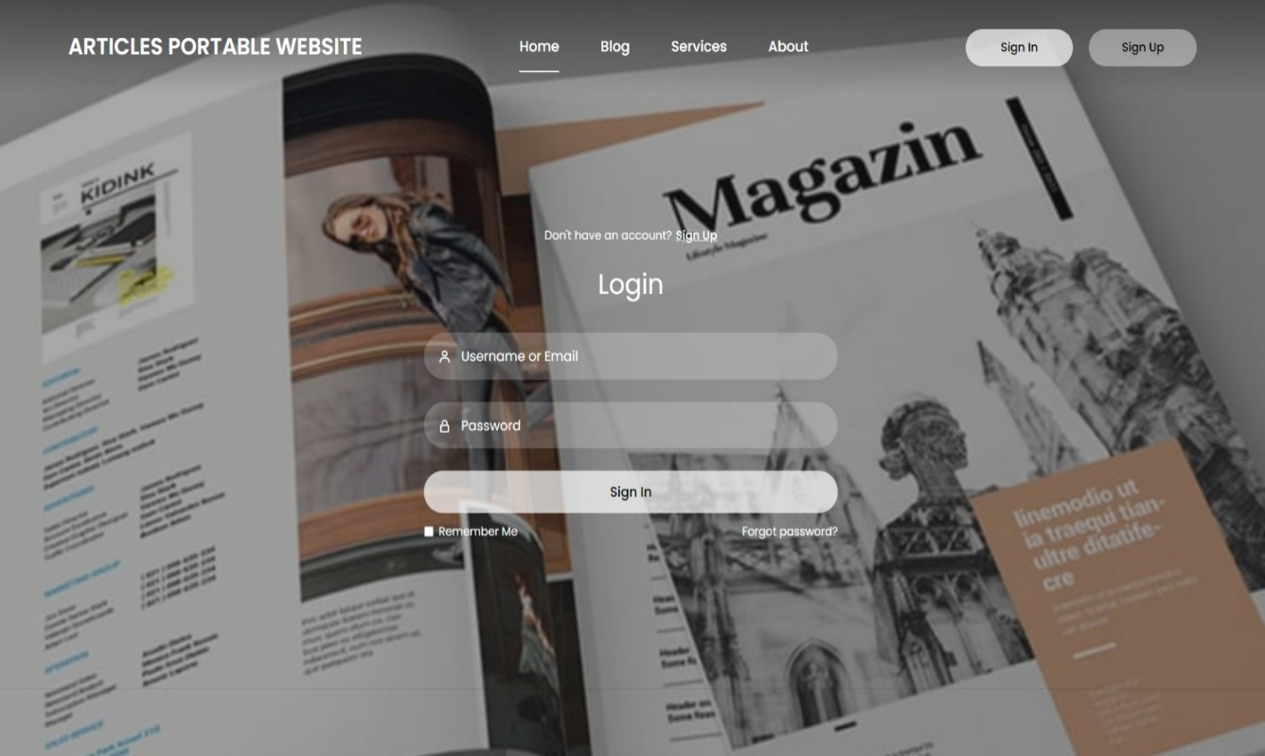

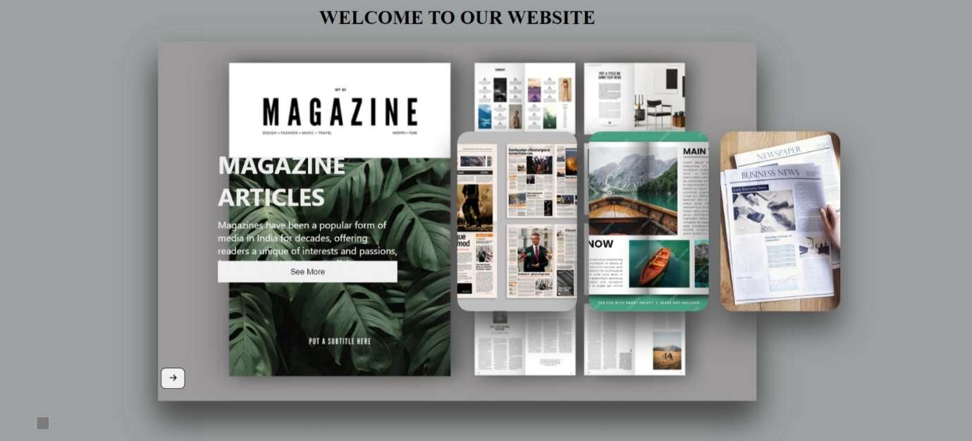



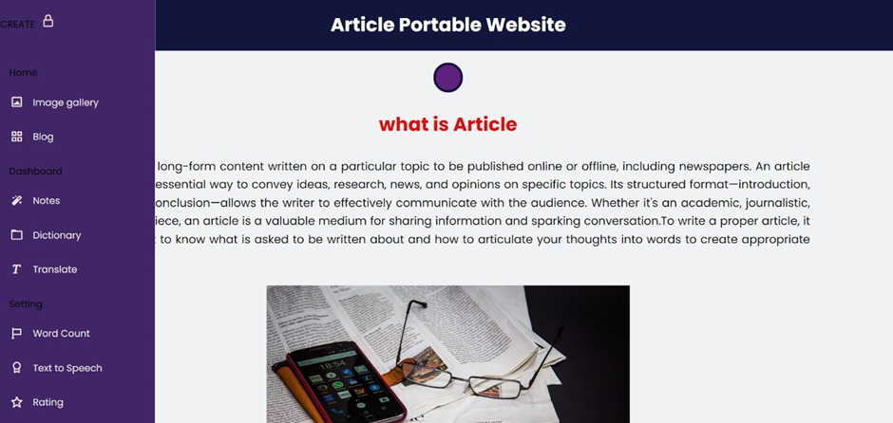

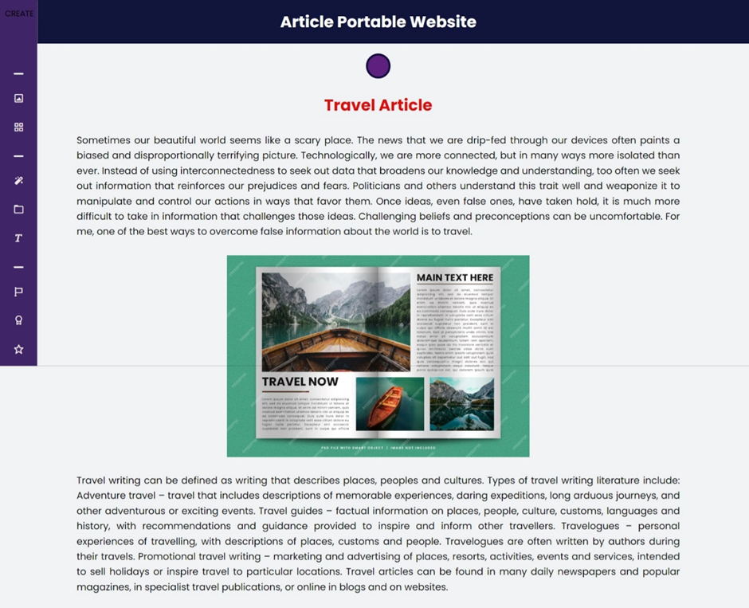



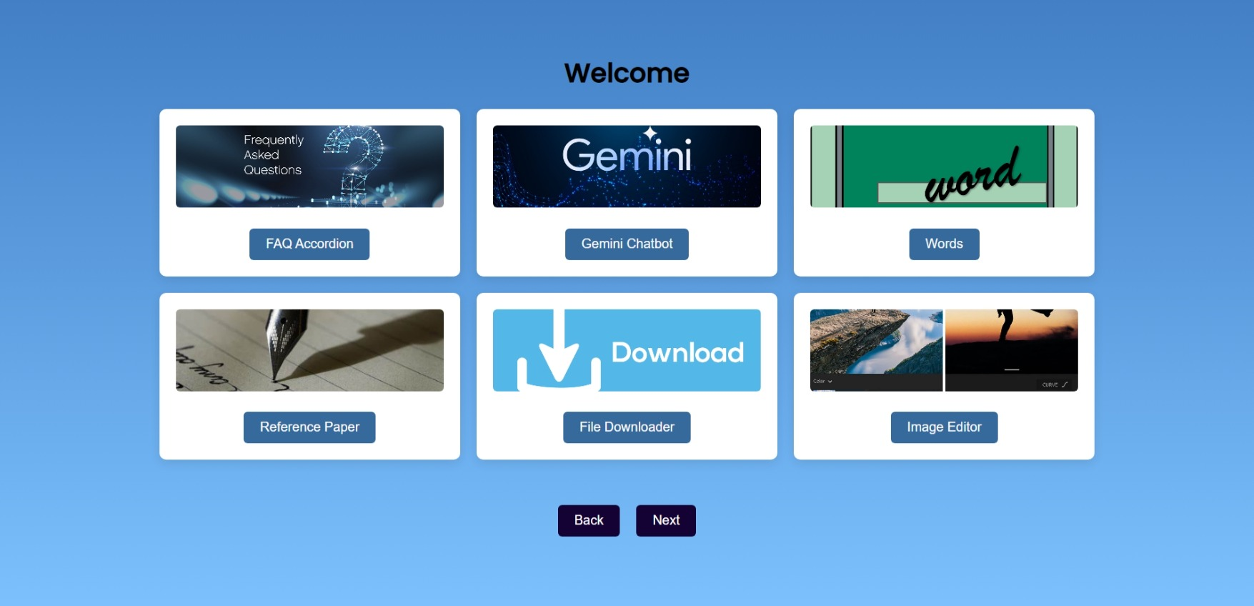

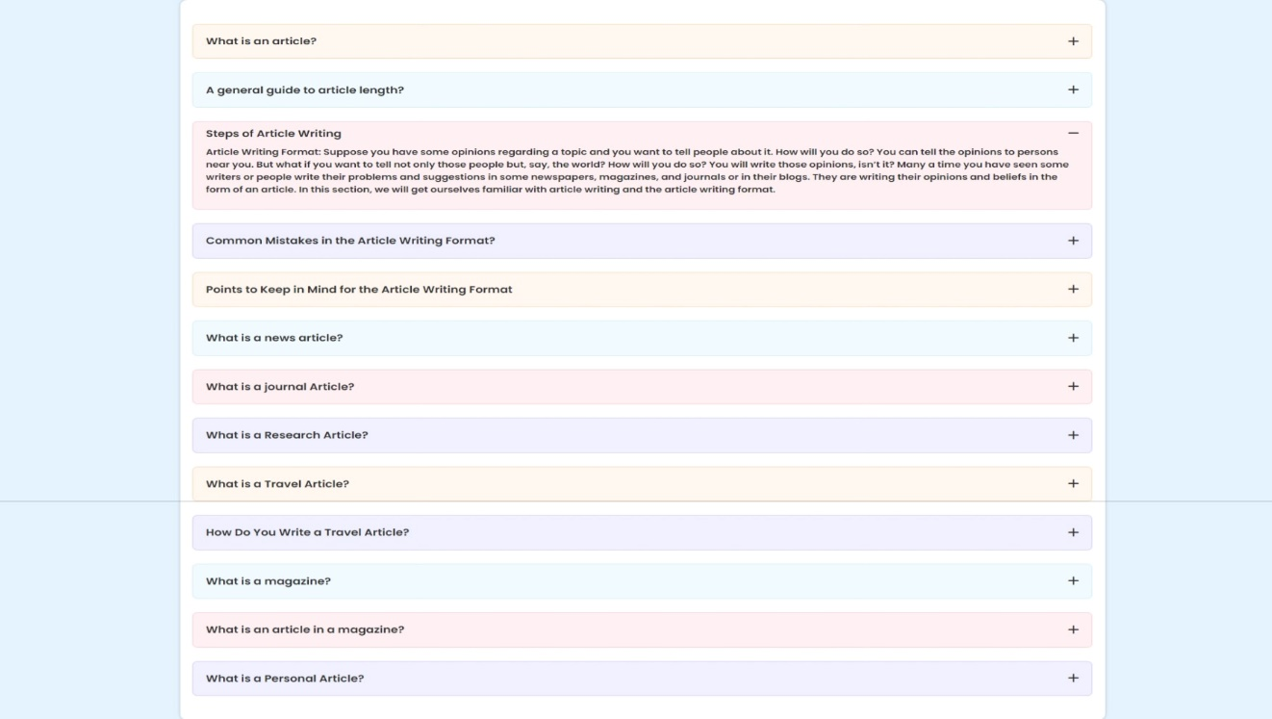

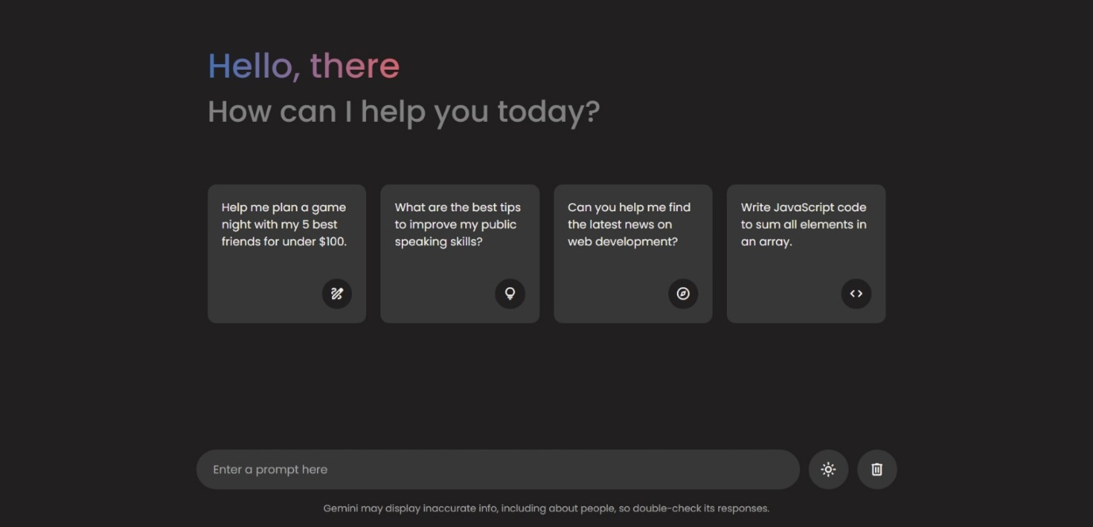

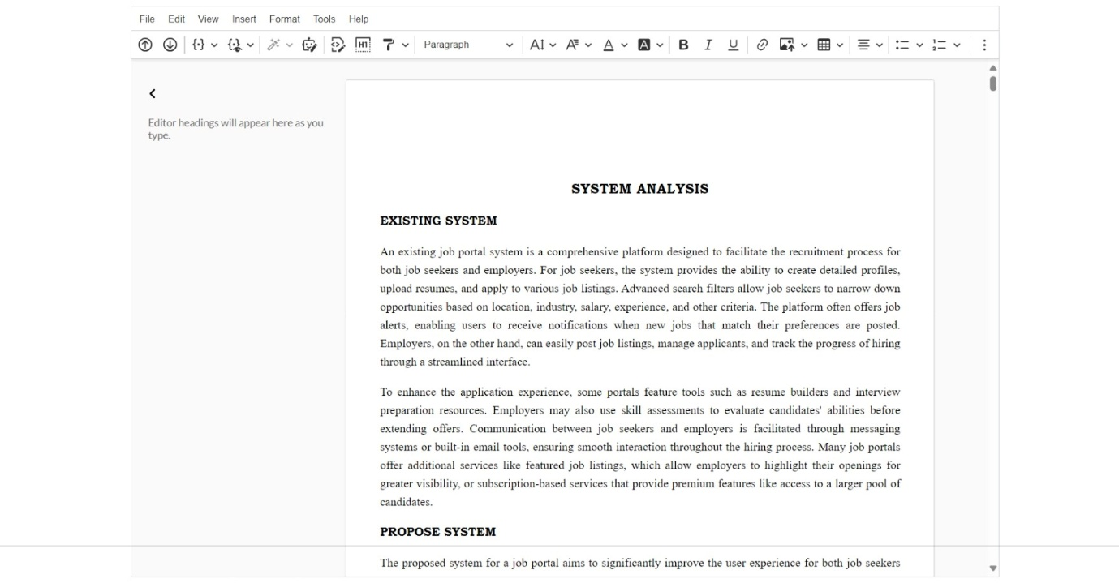

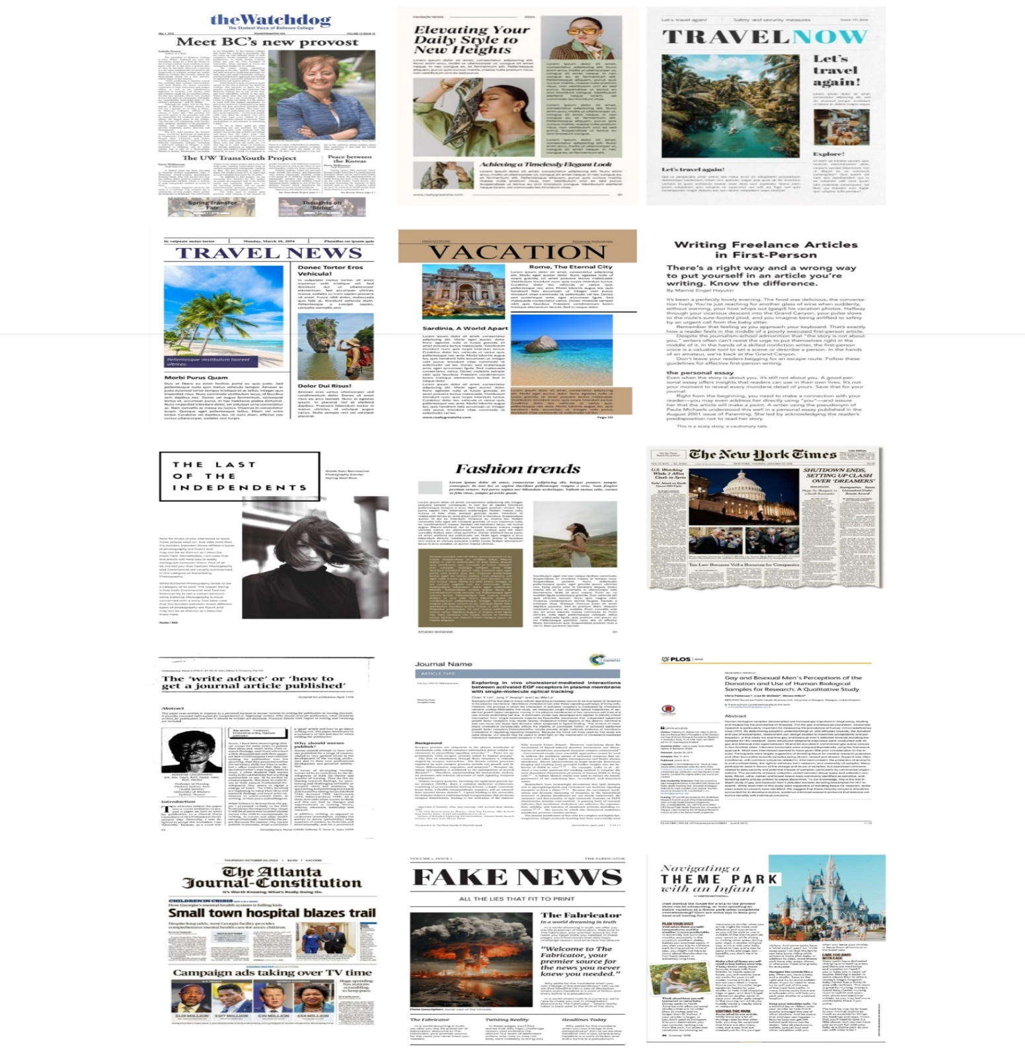

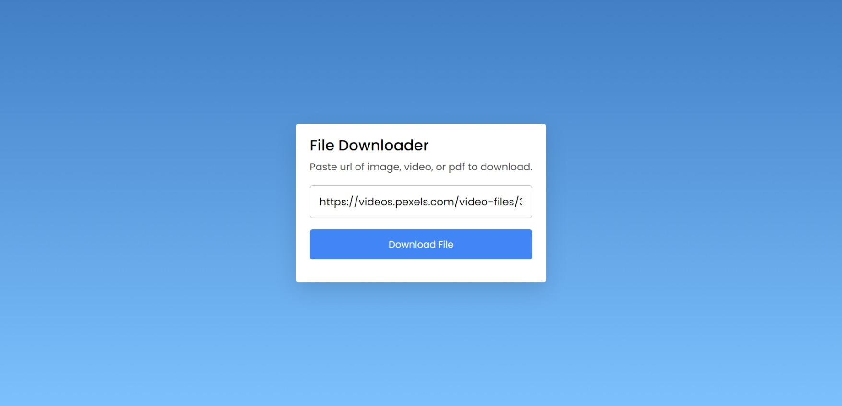

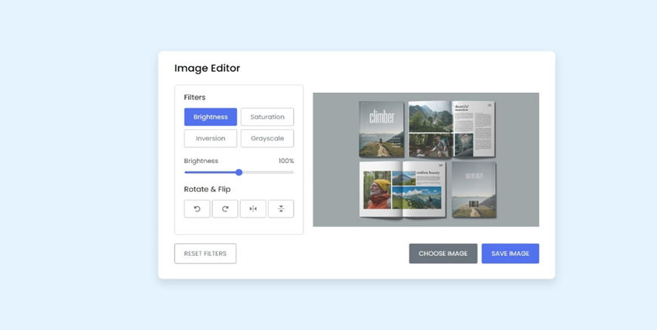



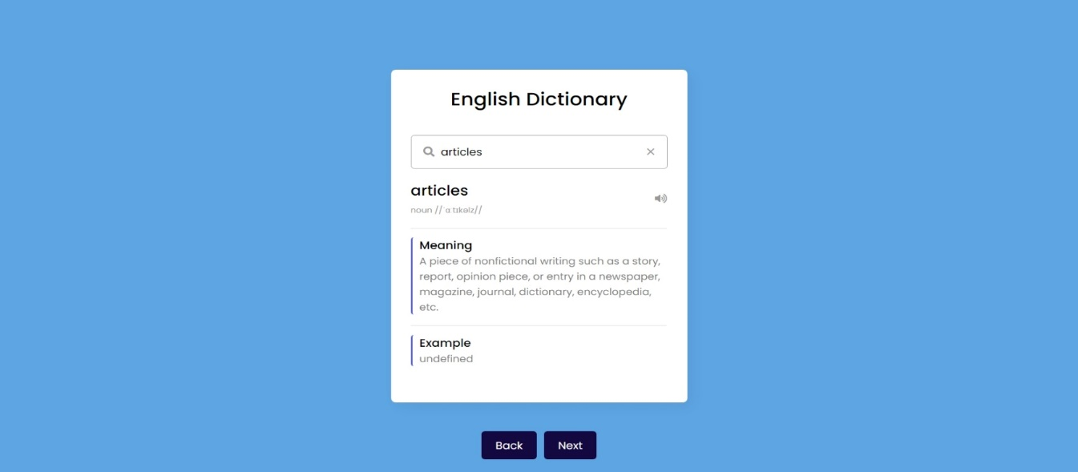

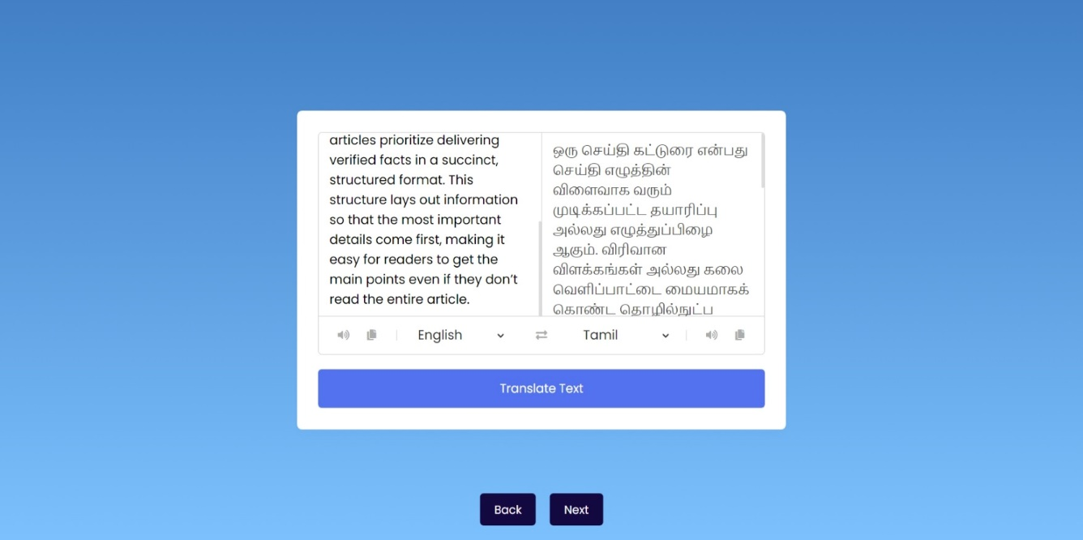

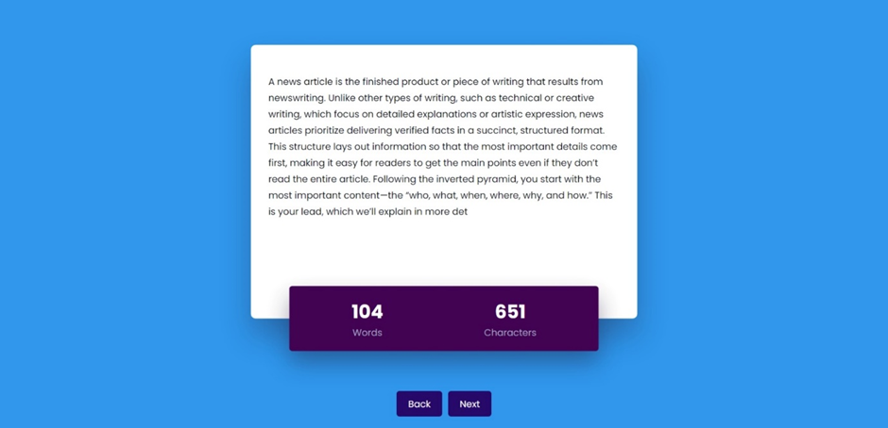

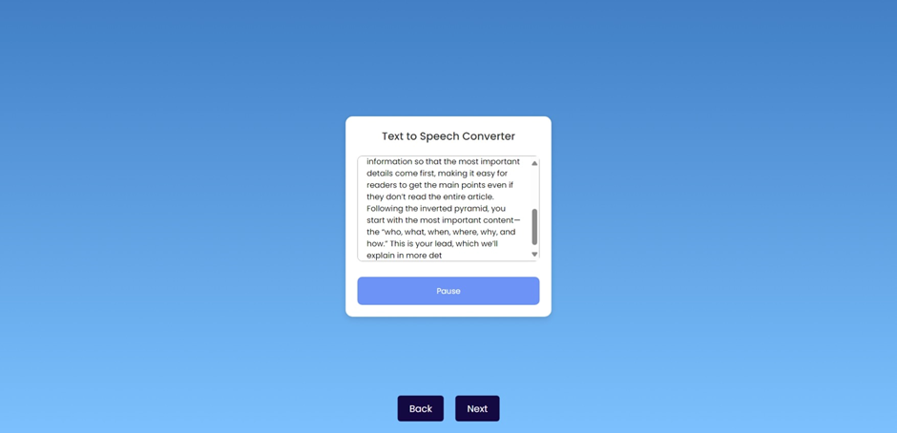

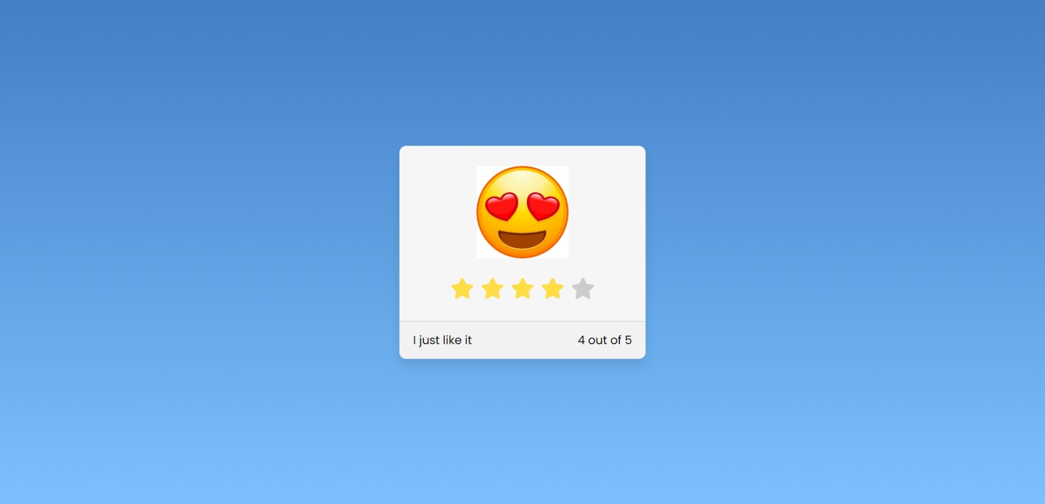

**CHAPTER 10**

**FUTURE ENHANCEMENT**

The platform will soon integrate AI-powered content recommendations, offering personalized article suggestions based on user interests and browsing behavior. Augmented Reality (AR) will be added for interactive content experiences, allowing users to engage with articles in new, immersive ways. Progressive Web App (PWA) capabilities will be implemented for offline access and improved mobile functionality, ensuring a more seamless user experience. Multi-language support will be introduced to cater to a global audience, expanding the platform’s reach and inclusivity. Advanced AI-driven analytics will provide deeper insights into user behavior, article performance, and engagement metrics, empowering content creators to optimize their content strategy. Real-time collaboration tools will allow multiple authors to co-create articles, fostering teamwork and productivity. The platform will also incorporate cloud storage solutions, ensuring scalable and efficient handling of large multimedia files. Two-factor authentication (2FA) will be introduced to enhance user security and protect sensitive data.Furthermore, integrated payment gateways will enable monetization options for content creators, such as subscriptions and pay-per-article models. The addition of voice search functionality will make it easier for users to find articles hands-free, enhancing accessibility. The introduction of video content support will allow authors to embed multimedia seamlessly, offering richer content experiences. The platform will also explore machine learning algorithms to enhance content curation and discoverability, ensuring that the most relevant articles are always visible to readers. Lastly, automated content moderation will help maintain quality by flagging inappropriate or irrelevant content, fostering a safer and more trustworthy environment for users. These enhancements will transform the platform into a robust, interactive, and future-ready content management solution.

**CONCLUSION**

In conclusion, the **Article Portable Website** offers a robust, versatile, and user-friendly platform for content creators to manage and publish articles. Built using **HTML, CSS, JavaScript, PHP, SQL, APIs**, and **CKEditor**, it provides a seamless experience across devices, with responsive design ensuring compatibility on desktops, tablets, and smartphones. The backend ensures secure user authentication and reliable article management, while **CKEditor** allows authors to create rich, media-integrated content. The platform's features include **user profiles**, **article categorization**, **SEO optimization**, and **social media sharing**, all designed to enhance engagement and content discoverability. APIs enable integration with external services, extending the platform’s functionality. Looking ahead, the platform plans to integrate **AI-driven content recommendations**, offer **Augmented Reality (AR)** for immersive experiences, and introduce **real-time collaboration** tools. Enhanced **security features**, including **two-factor authentication (2FA)**, will protect user data. **Cloud storage solutions** will help manage growing multimedia content, and **machine learning algorithms** will optimize content curation. This dynamic platform is designed for scalability, providing content creators with a powerful tool to establish a digital presence and engage a global audience. It will continue to evolve, meeting the needs of both users and technology, making it an ideal choice for content creation, management, and monetization.

**REFERENCES**

1. **Garrison, D. R., Anderson, T., & Archer, W. (2001).** Critical thinking, cognitive presence, and article publishing in digital platforms. The American Journal of Digital Publishing, 15(1), 7-23.
   * Explores the importance of cognitive presence and how it can be incorporated into online article platforms, ensuring articles are engaging, thought-provoking, and interactive for users.
2. **Miller, J. A., & Dinsmore, A. (2019).** Building a portable article website for the future: Key design principles and features. Web Development and Digital Publishing Research, 67(5), 939-961.
   * Focuses on design principles essential for article platforms, such as interactive content, dynamic article features, and reader engagement tools, all crucial for enhancing the user experience on an article-based website.
3. **Ally, M. (2004).** Foundations of content management theory for digital article platforms. The Theory and Practice of Online Publishing.
   * Provides a comprehensive look at content management theory, offering insights into how article platforms can be structured for effective content delivery, ease of management, and seamless user interaction.
4. **Pappano, L. (2012).** The Rise of Portable Article Platforms. The New York Times.
   * Discusses the growth of portable digital platforms and their influence on how content is created and consumed. This is relevant for article platforms that aim to provide seamless access to articles across various devices.
5. **Christensen, C. M., Horn, M. B., & Johnson, C. W. (2008).** Disrupting Article Publishing: How Technology Will Change the Way We Read. McGraw-Hill Education.
   * Explores how technological innovations are reshaping content publishing and the delivery of articles online, with a focus on how article platforms can adopt new tech like AI, mobile optimization, and cloud storage to stay ahead.
6. **Horn, M. B., & Staker, H. (2014).** Blended Content Consumption: How Interactive Features Enhance Article Platforms. Jossey-Bass.
   * This book provides insight into blending multimedia, interactive content, and dynamic engagement tools in article platforms, enhancing user experience and engagement by incorporating multimedia features and social sharing.
7. **Siemens, G. (2005).** Connectivism: A Learning and Sharing Theory for Digital Article Platforms. International Journal of Digital Publishing, 2(1).
   * Introduces connectivism, emphasizing the importance of social collaboration and sharing in digital platforms. Article platforms can use this theory to design features that allow readers to share articles, comment, and interact with the content and community.
8. **Bates, A. T. (2015).** Designing Effective Article Publishing Platforms: Guidelines for Creating Content and Engaging Readers. Tony Bates Associates Ltd.
   * A comprehensive guide on designing digital platforms for effective content creation and user interaction. These principles can be used to optimize article management, publication workflows, and enhance the user experience on the website.
9. **Ally, M., & Wark, N. (2004).** Critical Success Factors for Online Content Platforms: A Study of Digital Publishing. Canadian Journal of Digital Learning, 30(3).
   * Focuses on key factors for the success of digital content platforms, including user engagement, platform usability, content discoverability, and monetization strategies, which are essential for the growth of an article-based website.